**Singapore Polytechnic**

**ST0505: Enterprise Systems Development**

**Semester 1, 2021 / 2022**

**Project for CA1 Part 2**

**Prepared For: Ms Dora Chua Heok Hoon**

**Completed By: Sharysse Mojica Buenaventura, P2026552**

**Class: DIT/FT/2A/01**

**Date: 08/08/2021**

Table of Contents

**1 Create an AWS account** 1

**2 Hosting Backend Server in Amazon EC2** 3

2.1 Create an EC2 Instance 3

2.2 Download PuTTY 6

2.3 Downloading WinSCP 9

2.4 Connecting to the EC2 Using WinSCP and PuTTY 12

2.5 Assigning an Elastic IP to the backend EC2 instance 20

**3 Creating a RDS database** 23

3.1 Creating a RDS database 23

3.2 Connecting the RDS database to the MYSQL Workbench 26

3.3 Data Encryption of RDS Database 31

3.4 Database Logging 36

3.6 Configuring User Privileges for the Database 38

**4 Creating a DynamoDB Table** 39

4.1 Creating a Cloud9 Environment 39

4.2 Create a DynamoDB table 43

4.3 Importing Data into DynamoDB 45

**5 Creating a Lambda Function** 50

5.1 Creating a Lambda Function 50

5.2 Configuring Lambda Role Permissions 51

5.3 Creating a Lambda Query 55

**6 Creating an API with API Gateway** 60

6.1 Create an API 60

6.2 Create API GET Method 62

6.3 Testing of API 67

6.4 Implementing the API into Frontend Server 70

**7 Setting Up CloudWatch Logging For Created API** 72

7.1 Create CloudWatch Role 72

7.2 Creating a Log Group 75

7.3 Add CloudWatch IAM Role to API Gateway 77

7.4 Testing the CloudWatch Logging 80

**8 Cloud Trail** 82

## **1 Create an AWS account**

To start with deploying web services using AWS cloud computing you will need to create an AWS account.

Using the following link create an AWS account

<https://portal.aws.amazon.com/billing/signup#/start>

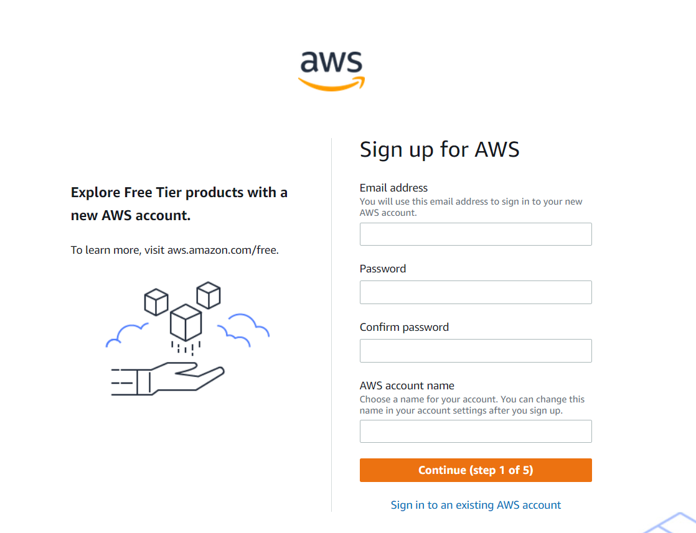

After successfully creating an AWS account, login the account and make payment to be able to use the AWS services using credits.

The following are the different payment methods available for AWS pick which one fits your preference and budgeting:

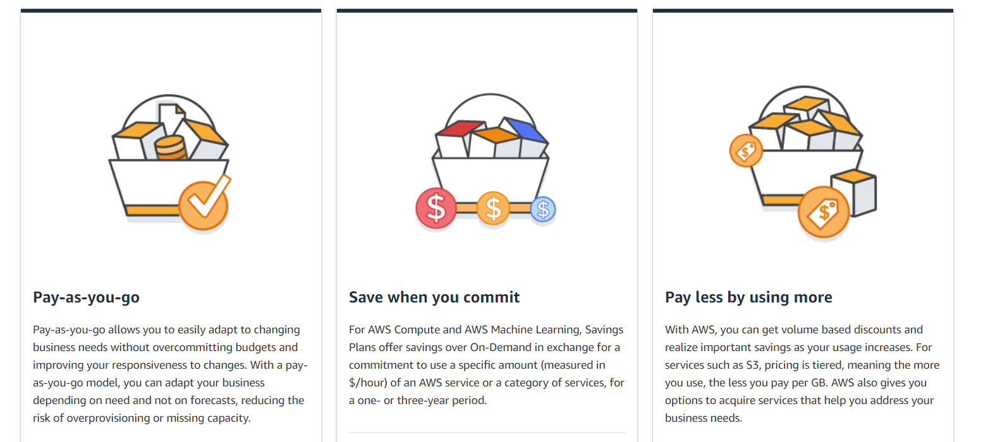

To find out more of the pricing, click on the following link: <https://aws.amazon.com/pricing/>

## **2 Hosting Backend Server in Amazon EC2**

Firstly, we need to create a virtual server that will enable us to host the backend server of the website. Amazon EC2 allows you to dispatch as numerous or as few virtual servers as you wish, configure security and networking, and manage storage. Amazon EC2 empowers you to scale up or down to handle changes in necessities or spikes in ubiquity, diminishing your need to estimate activity.

### 2.1 Create an EC2 Instance

Step 1: Upon logging in your AWS account, search “EC2” and click on the following:

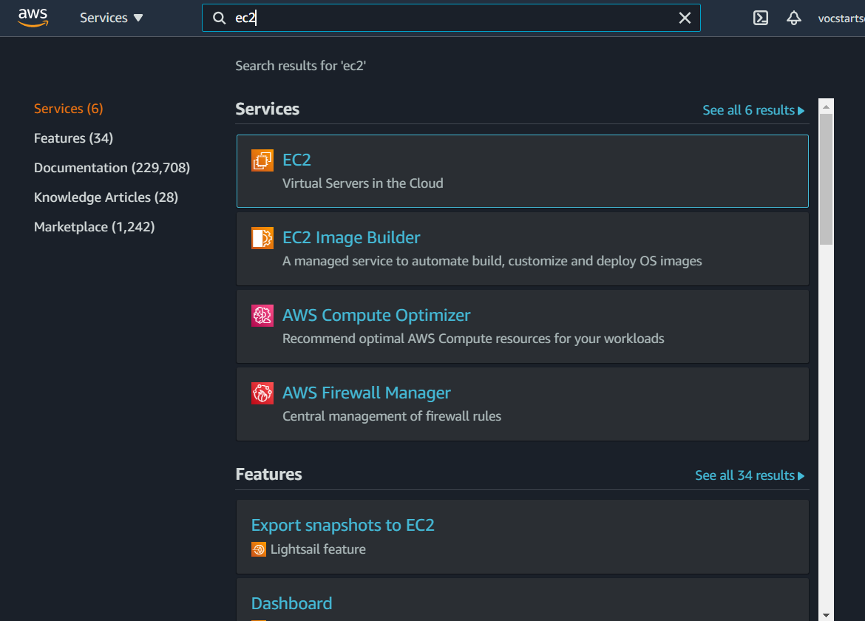

Step 2: Click on instances and click on launch instances.

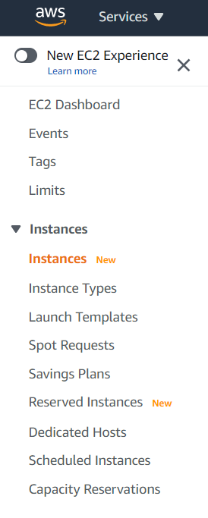

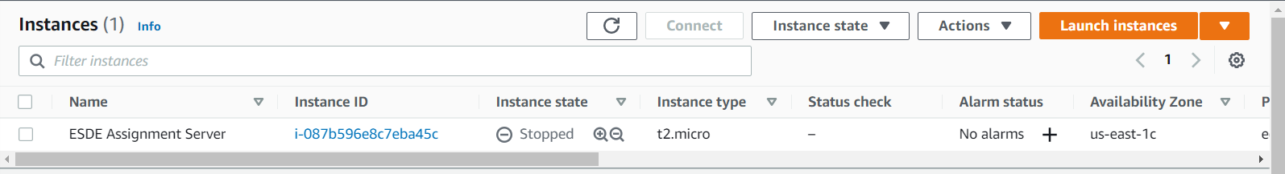

Step 3: Select Ubuntu Server 18.04 LTS (HVM), for the Amazon Machine Image (AMI).



Step 4: Select the following for the instance type family:

t2, type: t2 micro, vCPUs : 1, memory (GiB) : 1,

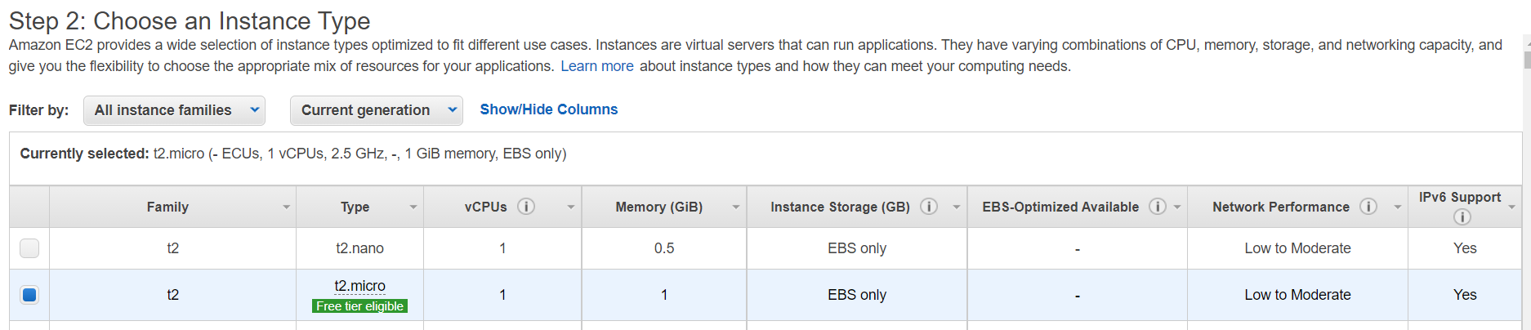

Step 5: Click on “Next: Configure Instance Details”, “Next: Add Storage” and “Next: Add tags” leaving the default settings for both sections.

Step 6: Click on “Next: Configure Security Groups” and change the security group name and description to your preference and it should allow you to know what it is for.

Eg: Security Group Name: ESDE-Assignment-Server-SecurityGroup

Description: ESDE-Assignment-Server-SecurityGroup

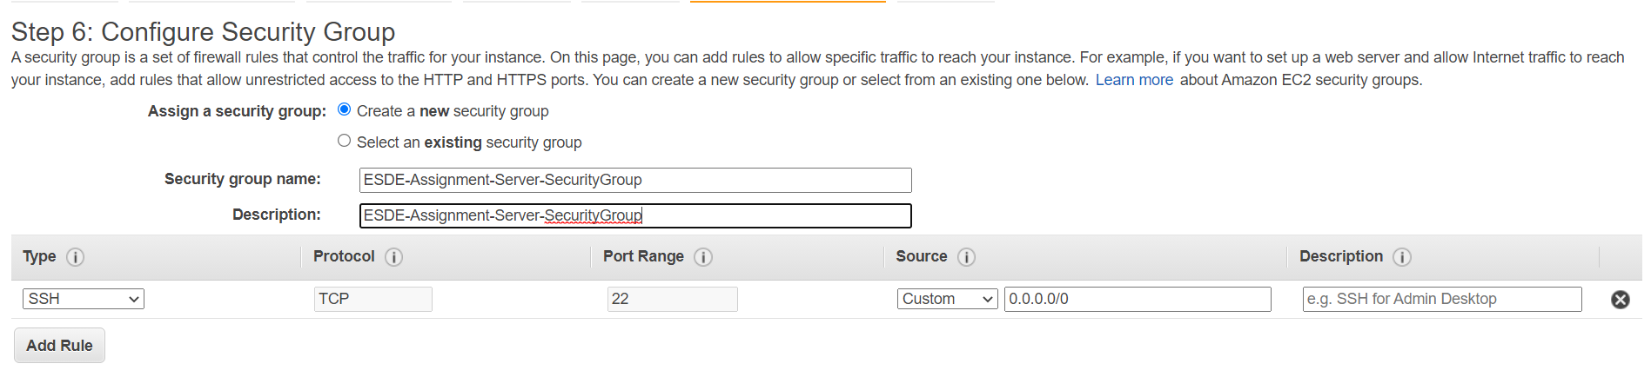

Step 7: Click on “Review and launch” and check that each section is correct. Click on “Launch”, with this you should have created an EC2 instance.

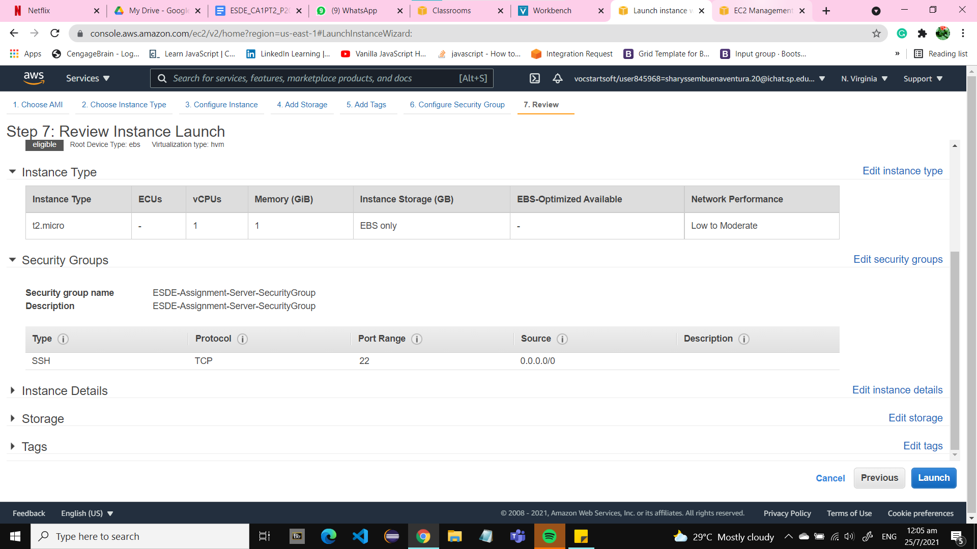

Step 8: After you Click launch you will be prompted to create and download a private key. This key will allow you to connect to your instances with SSH. If you don’t download this, or delete it somehow, you won’t be able to connect to your cluster. Should you lose it, you can just terminate the existing instance and create a new one.

Name your keypair that correlates with your project, so it is easier to find and use.

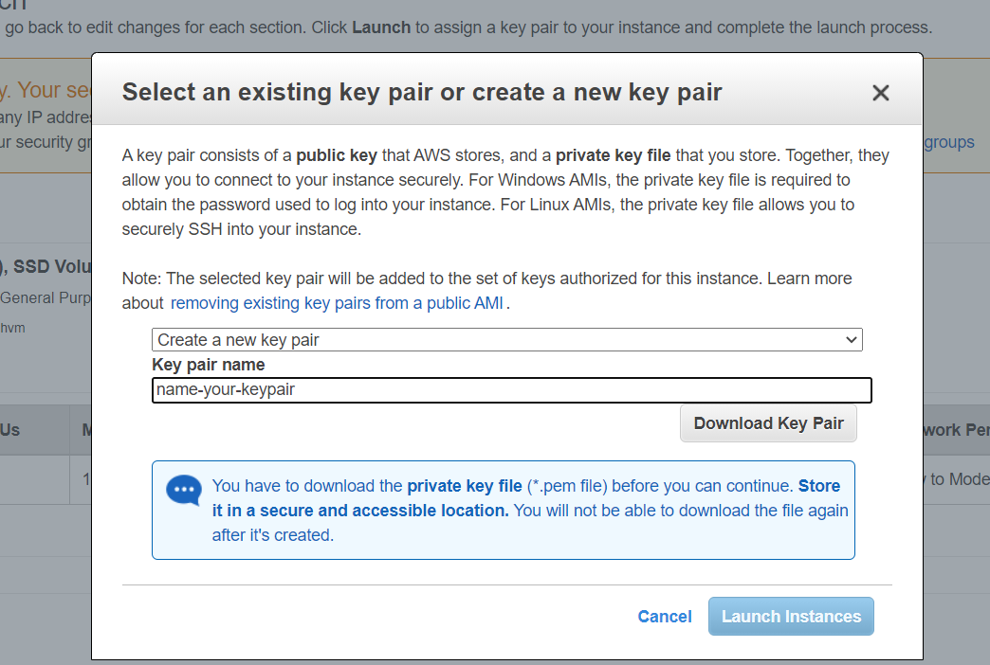

Step 8: Change the name of the instance to the function such that you can differentiate it other future instances.

Eg: ESDE Assignment Server

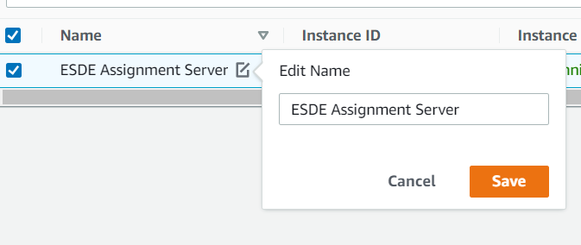

Step 9: Check that the instance is successfully running by using the following as a comparison:



With this you have successfully created an EC2 instance.

### 2.2 Download PuTTY

Step 1: Using the following link download PuTTY.

Select the MSI(‘Windows Installer’) 64-bitx86: putty-64bit-0.76-installer.msi

<https://www.chiark.greenend.org.uk/~sgtatham/putty/latest.html>

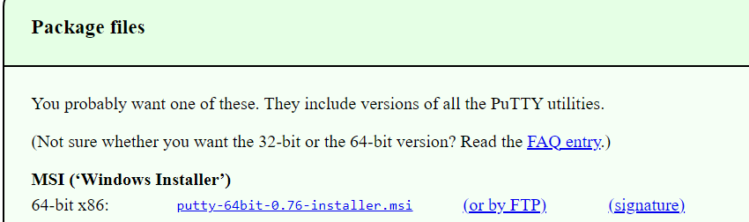

Step 2: Click on the downloaded item and press “Next” until you reach the install page.

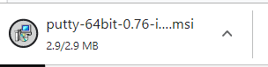

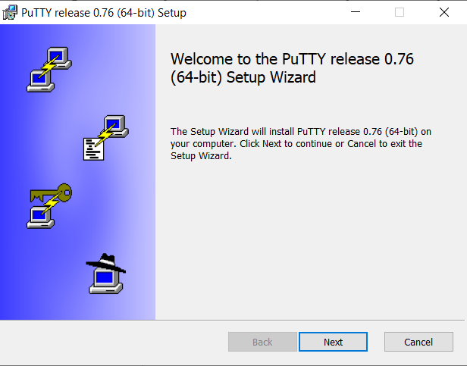

Step 3: Click on “Install”.

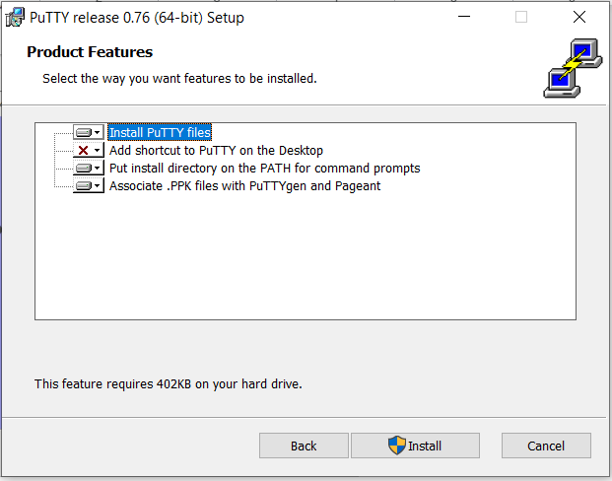

Step 4: Click on “Finish” and now you have successfully downloaded PuTTY.

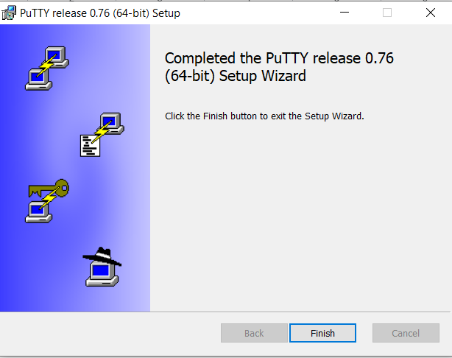

### 2.3 Downloading WinSCP

We will be using WinSCP as it allows multiple PuTTY windows to be open at once as well, we will be able to upload the relevant files in a more efficient and easy way using WinSCP.

Step 1: Using the following links download WinSCP.

<https://winscp.net/eng/download.php>

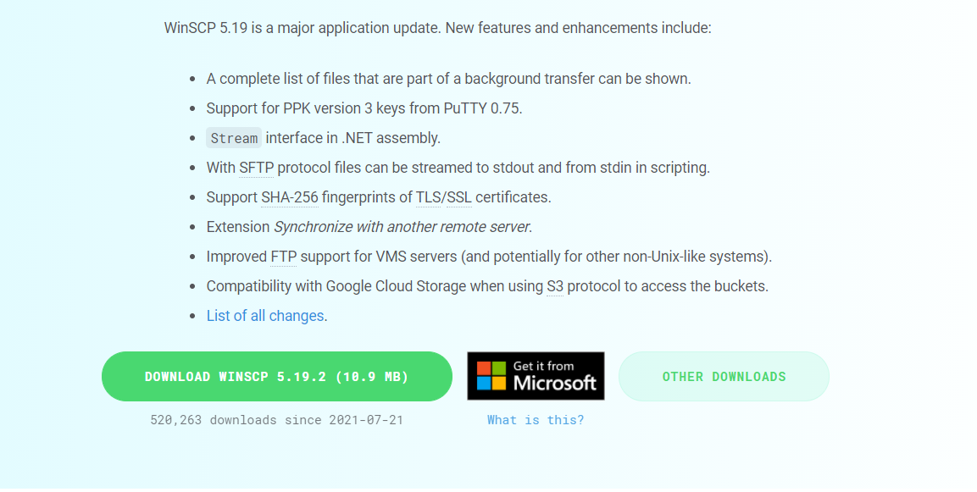

Step 2: Click on the downloaded item.

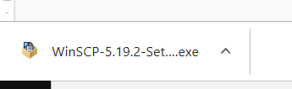

Step 3: Click on “Accept” to start setting up the WinSCP.

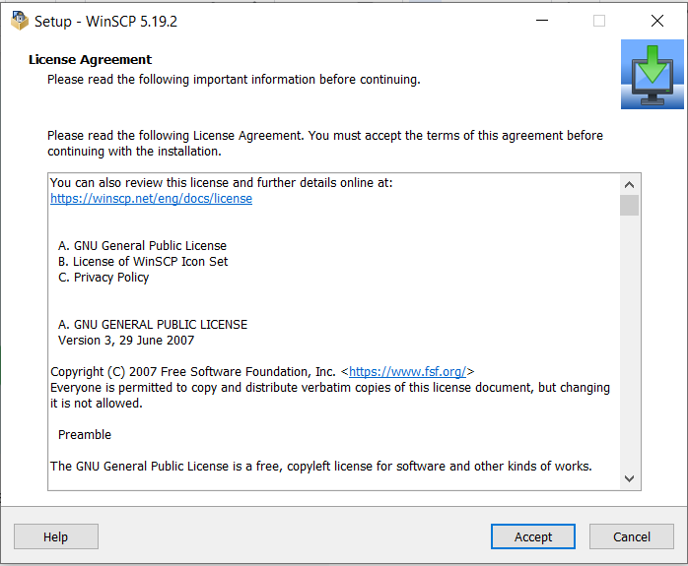

Step 4: Click on “Next” and install the WinSCP.

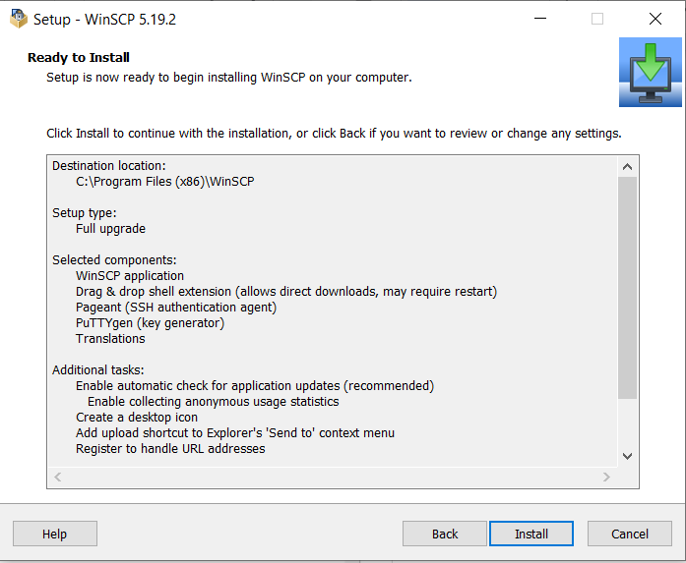

Step 5: Click on “finished” where you will be redirected to a browser donate to the organisation, this is optional.

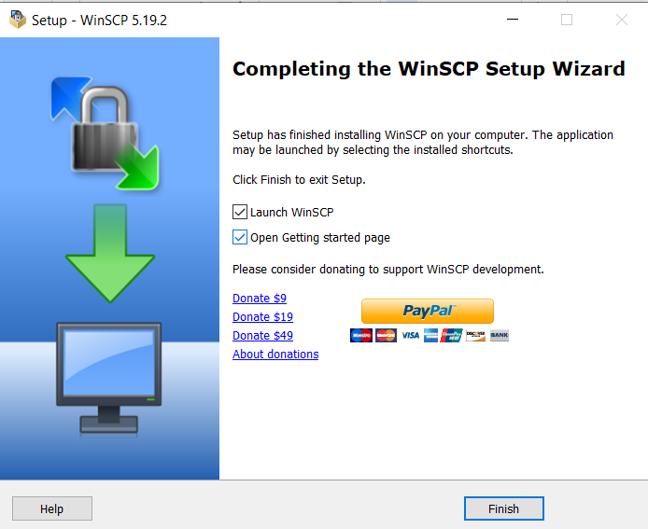

With this you have successfully downloaded WinSCP.

### 2.4 Connecting to the EC2 Using WinSCP and PuTTY

Now we will be connecting our created EC2 instance to the backend server as well as uploading all the backend and frontend files into WinSCP to be able to get the website running.

Step 1: Ensure that your EC2 is running as if it is not, you will not be able to log in.

Step 2: Open WinSCP and you will be prompt to login as soon as the WinSCP window loads.

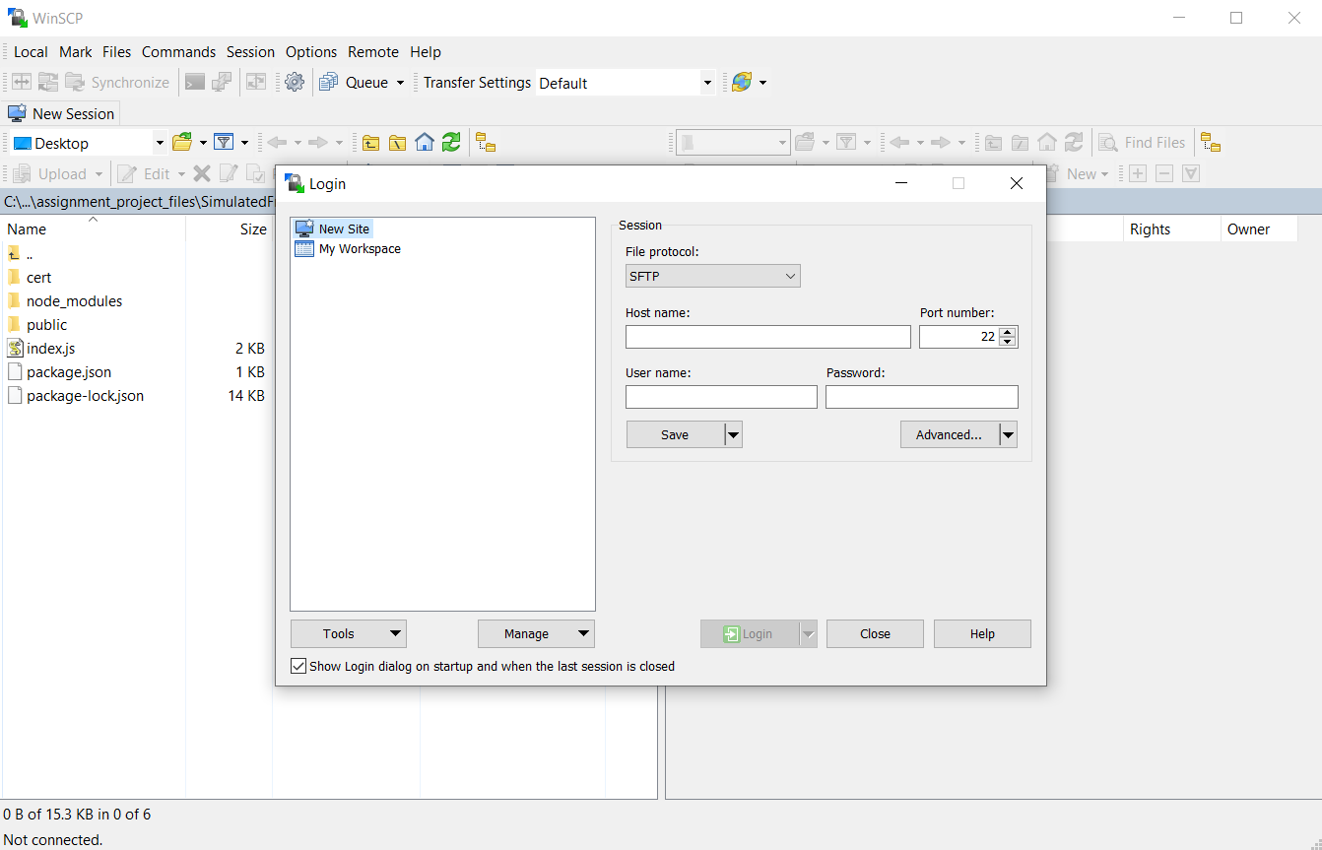

Step 3: Click on the “Advanced…” button and go to “Authentication” under SSH. You will insert your private key file by clicking on the “...” and navigating to the folder where you have stored your private key file.

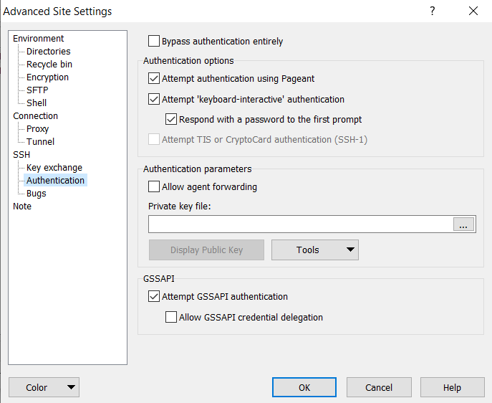

As your file would be saved .pem you will need to change to “All files” option.

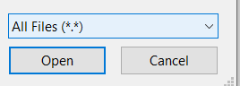

Click on the private key file where you will be prompted to convert the file into .ppk

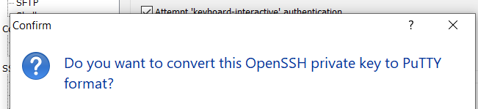

Step 4: Go to “Tunnel” under connection, click the checkbox that states “Connect through SSH tunnel”. For username put “ubuntu”, leave the password blank as we did not set a password and hostname is the public IPv4 address from your EC2 instance.

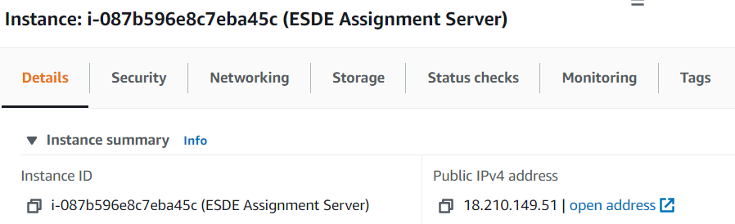

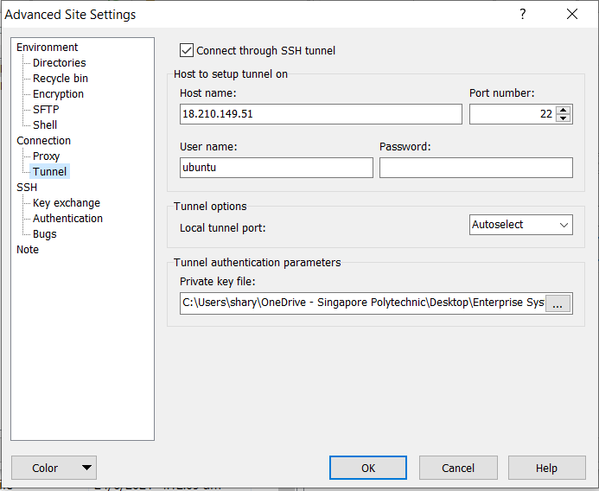

Step 5: Click on the “OK” button and enter the same details for hostname, username leaving the password blank. Afterwards, click on the login button.

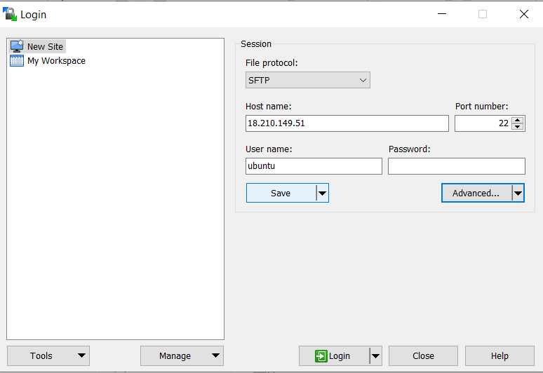

Step 6: After successfully logging in, we can now start transferring files. In the Ubuntu side of the WinSCP create a folder or one folder each where you will store your frontend and backend files. Double click on the created folder to direct into the folder.

Eg: I created only 1 main folder which will store both frontend and backend folders named “files”.

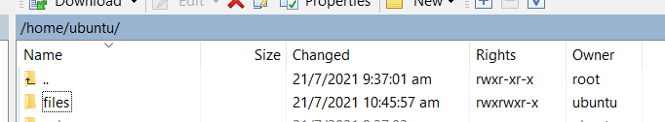

In your local side of the WinSCP go to the folder path that stores your frontend files. Ensure that the folder does not contain node_modules as it will take a long to upload to Ubuntu. Afterwards, right-click on each folder and click on “Upload” to do the same for the backend files.

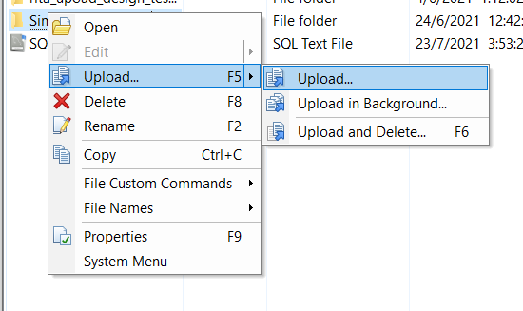

Step 7: Open the index file in both frontend and backend folders, change the base url such that the ‘localhost’ or hostname is your IPv4 address from the EC2 instance.

Eg: frontend index.js file

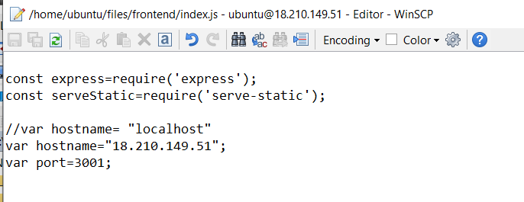

Step 8: Go to your EC2 instance on the side menu, click on “Security Groups” under Network & Security.

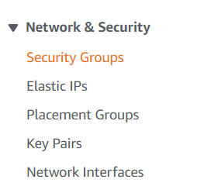

Step 9: Click on the security group for your EC2 instance.

With the inbound rules both the frontend and backend server will not be able to run properly hence we will need to create new inbound rules to enable the servers to run.

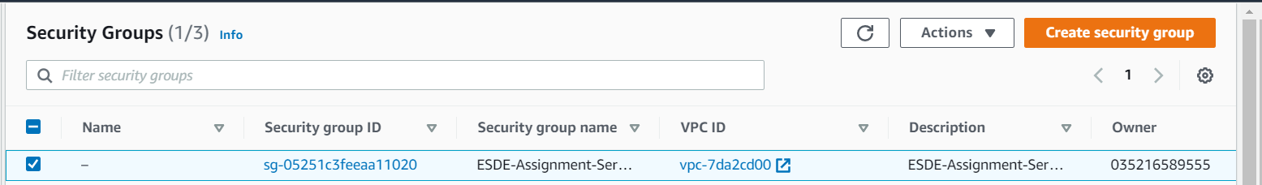

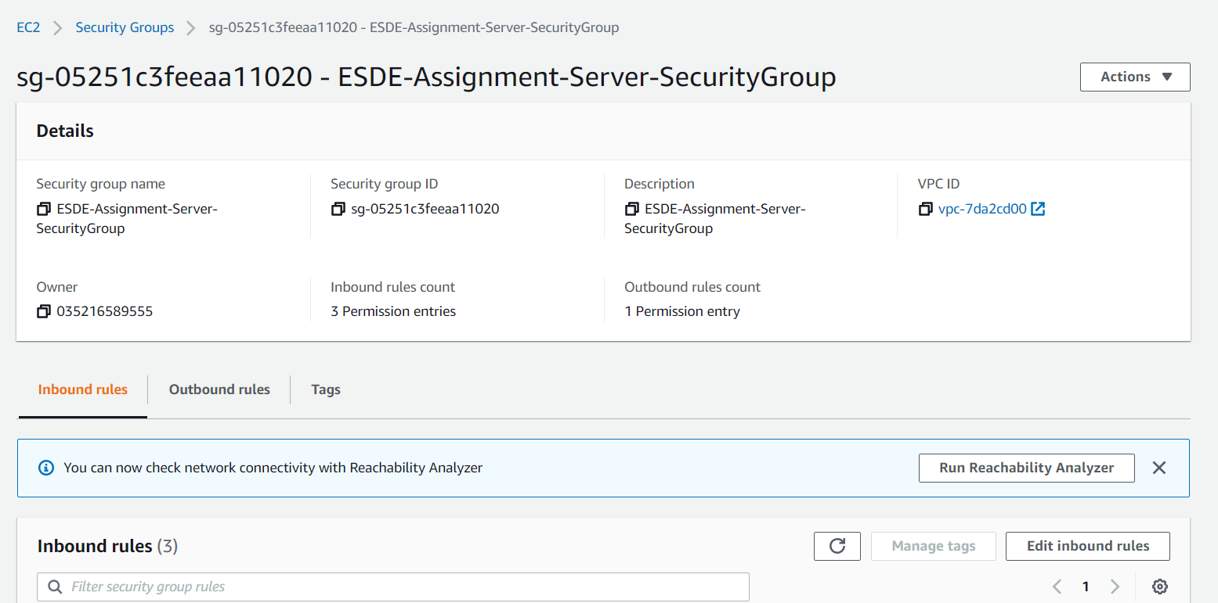

Step 10: Scroll down and press the “Edit inbound rules” under the “Inbound rules”

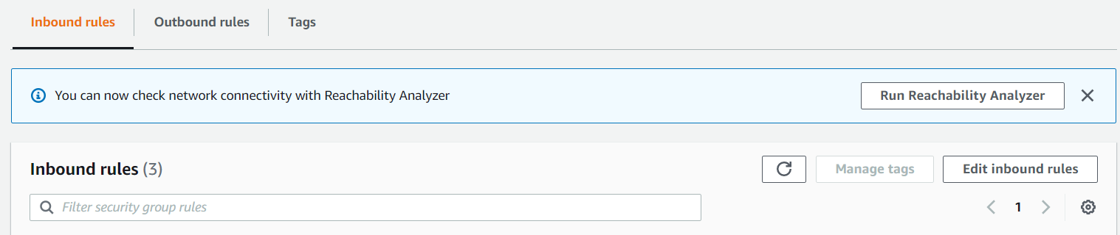

Step 11: Add two new ports “3001” & “5000”, both are custom TCP type, anywhere-IPv4 source with 0.0.0/0.

It should look like the following:

Eg: Port 3001

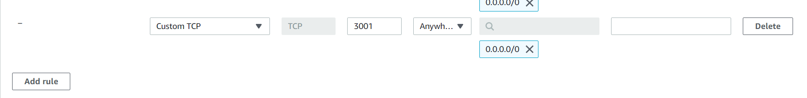

After clicking on the “Save changes” button this would be how it would look like:

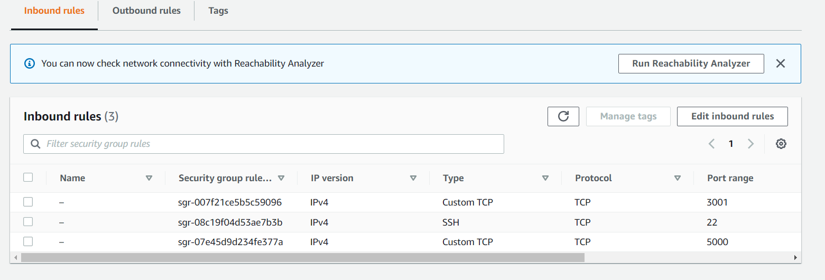

Step 12: On the tools bar click on the following to open the current session in PuTTYgen. Open two PuTTYgen terminals as we will need one each for frontend and backend servers.

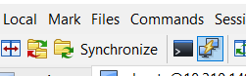

Step 13: Run the following commands for each PuTTY gen, this will install node_modules and npm package to run commands for both frontend and backend servers.

* Sudo apt update
* Sudo apt install node.js
* Sudo apt install npm
* Node.js -v
* Npm install

Step 14: You can now run the frontend and backend servers respectively using the following codes:

Node index.js

Or

Step 15: For automatic saving of changes made in both servers you can install nodemon using the following code: (Optional)

Npm install nodemon --save

You can then use the following code to start both servers:

Npm run start

Step 16: As we are using openSSL ,https, we would be blocked on browsers and we will need to change some browsing settings to enable it to work.

For Google Chrome: <https://support.google.com/chrome/answer/114662?hl=en&co=GENIE.Platform%3DDesktop>

For firefox:

<https://support.mozilla.org/en-US/questions/1159231>

For microsoft edge:

<https://www.windowscentral.com/how-manage-site-permissions-new-microsoft-edge>

With this you have successfully connected your EC2 instance using WinSCP and PuTTYgen. However, you will not be able to access other parts of the website such as login page just yet as we will need to further modify the codes accordingly in the next section.



### 2.5 Assigning an Elastic IP to the backend EC2 instance

With your current EC2 instance, every time the instance is stopped a new public IP address is assigned and this will result in having to change the hostname every time the instance has started running. To solve this problem, we will be assigning an Elastic IP address which will be the permanent IP address for the EC2 instance it is assigned.

Step 1: Go to your EC2 instance and go to “Elastic IPs” under “Network & Security”.

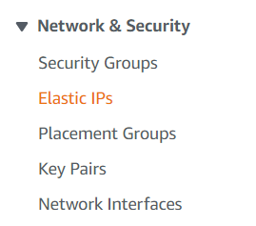

Step 2: Click on “Allocate Elastic IP address”.

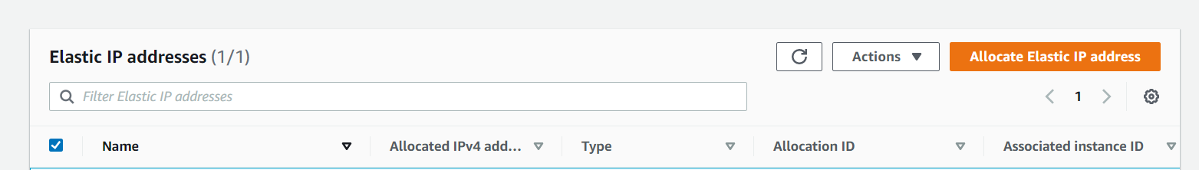

Step 3: set the elastic IP address settings by default, scroll down and press “Allocate”.

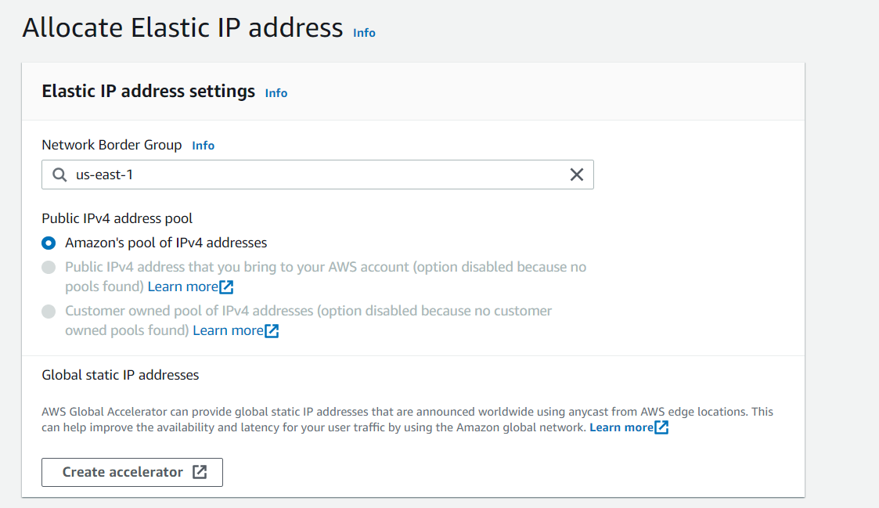

Step 4: After successfully allocating an elastic IP address, click on “Associate Elastic IP address”.



Step 5: With the resource type as instance, choose the EC2 instance you are currently using and enter the current private IP address of your instance, found under “Private IPv4 address” in the details of your EC2 instance. Afterwards, click on the “Associate” button.

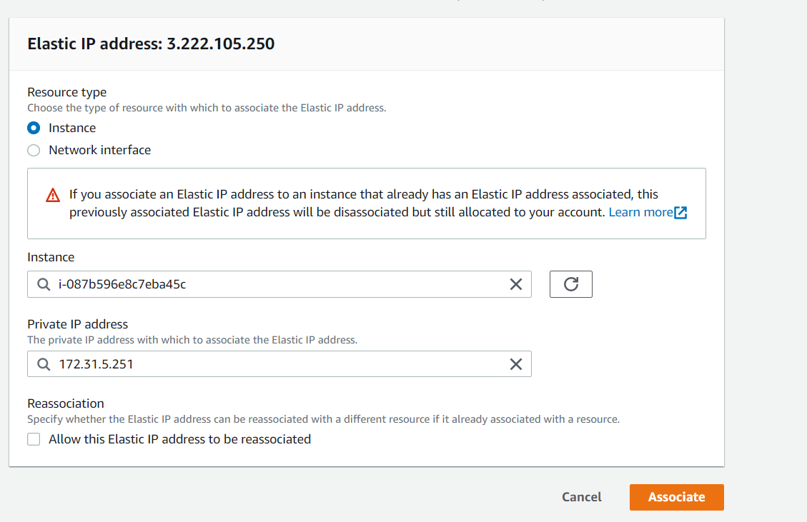

Step 6: Copy the new public IPv4 address and go back to WinSCP. You will be prompted to login again and you will change the hostname to your new IP address as well as the advanced setting for “Tunnel” under “Connection”. You can now login again.

Step 7: Change all of the hostname in the base URL in all the javascript files for both frontend and backend server.

Eg: frontend login.js

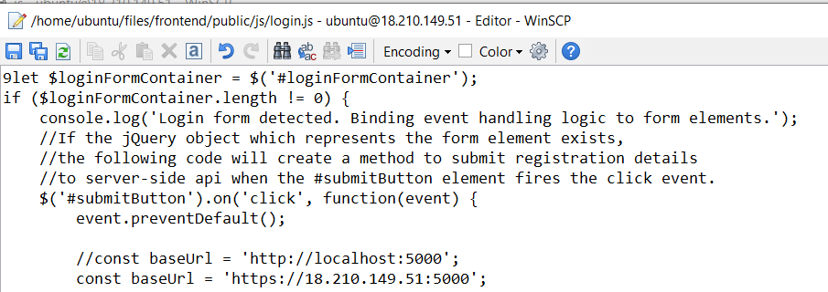

Step 8: Rerun the frontend and backend servers with the new IP address.

You have now successfully created an elastic IP address for your EC2 instance.

## **3 Creating a RDS database**

We will need a database to store all of our data which was previously stored in MYSQL workbench. Relational Database Service (RDS) database will be connected to your EC2 machine and provides a database instance, changes any configuration settings and makes the instance available for the user.

### 3.1 Creating a RDS database

Step 1: In the search bar of your AWS account, search “RDS database” and click on the following:

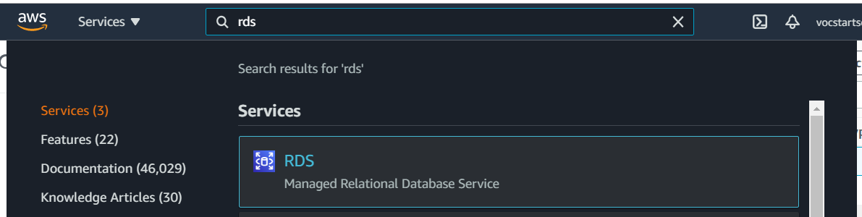

Step 2: Click on the “Databases” from the side menu.

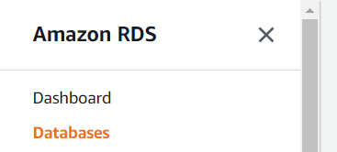

Step 3: Click on the “Create database” button.

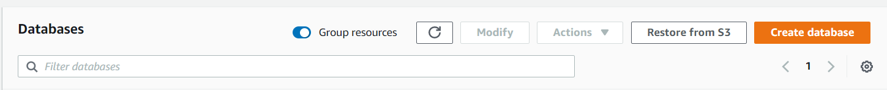

Step 4: Do the following settings for the database. For the database creation method leave it as default “Standard Create”, engine type choose “MYSQL”, templates choose “Free Tier”.

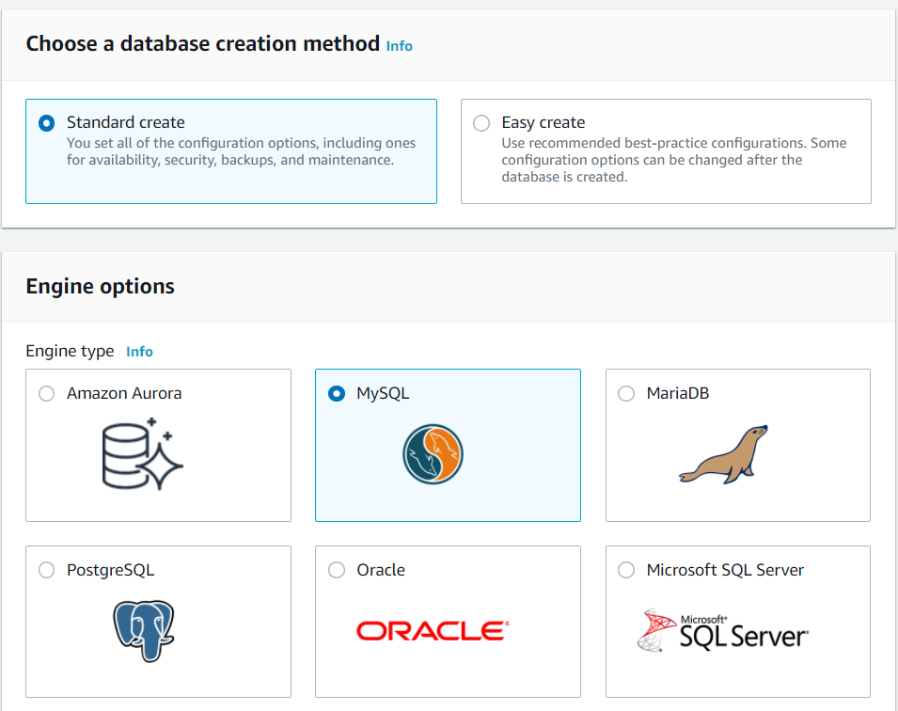

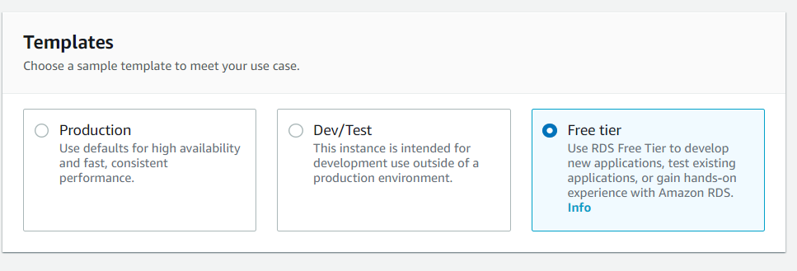

For the settings, you can leave the database name as default or preferably change it so that you can know what the database is for. Leave the master nickname as “Admin” and create a master password and confirm the password. We will be using the password to create a MYSQL workbench connection.

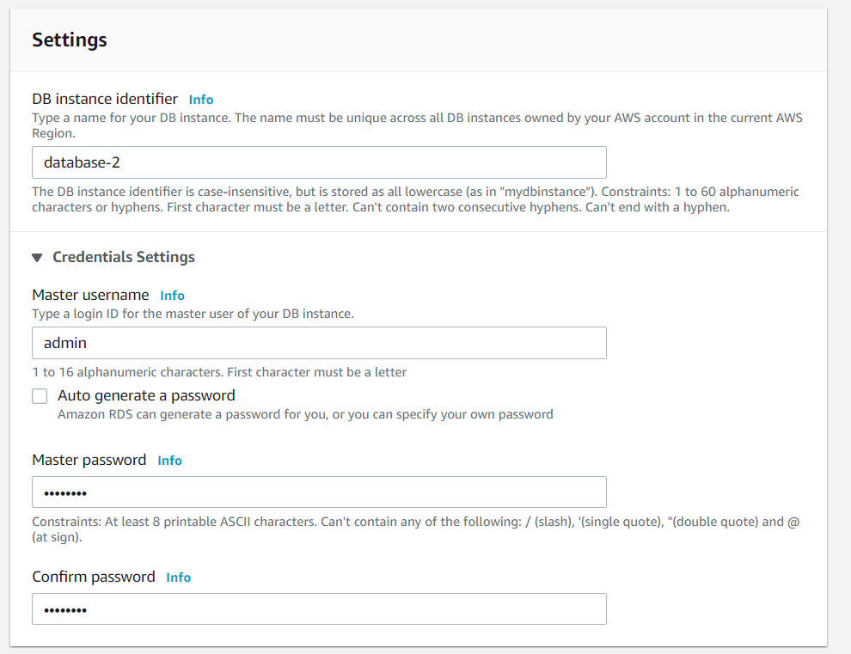

As for DB instance class, storage, availability & durability, connection and database authentication by default.

Step 5: Click on the “Create database” button, it should look like the following.

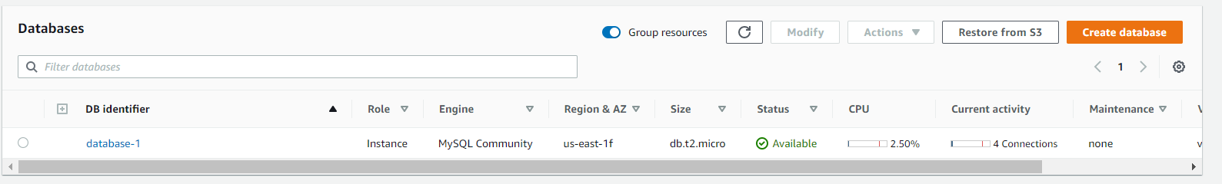

### 3.2 Connecting the RDS database to the MYSQL Workbench

Step 1: View the RDS database details, under the “Security group rules” click on the first security group. You will then be redirected to the EC2 management for the selected security group.

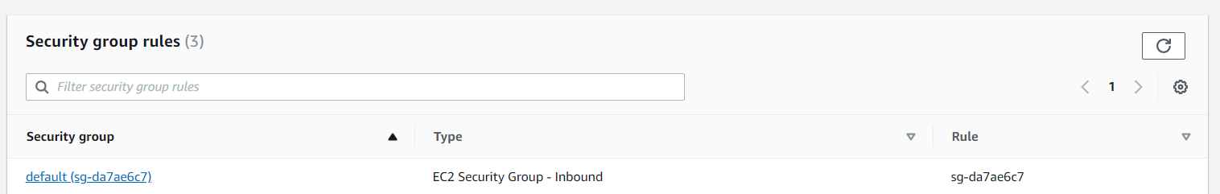

Step 2: Under the Inbound rules, click on the “Edit inbound rules” button.

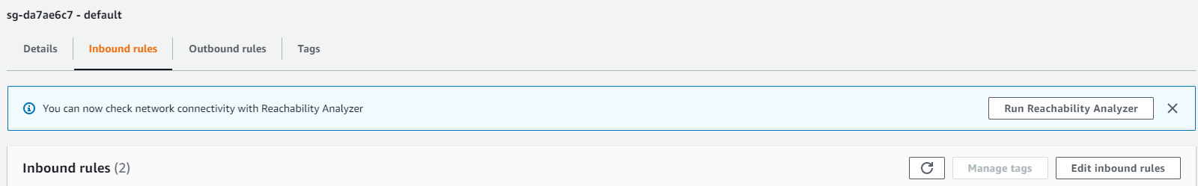

Step 3: Click on the “Add rule” button, for the type select “MYSQL/Aurora” and source select “Anywhere-IPv4”. Click on the “Save rules” button.

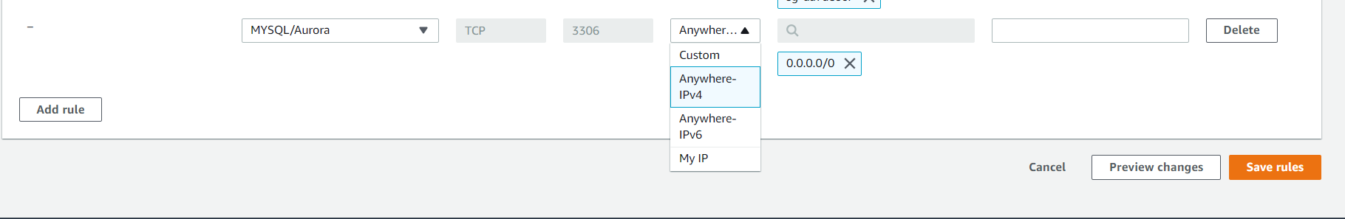

Step 4: Open up your MYSQL workbench and press the “+” button, you will be creating a new connection.

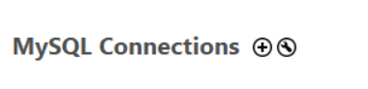

Step 5: Do the following for the settings :

Connection name : AWS EC2, Connection method : Standard (TCP/IP),

Hostname can be found in under connectivity & security of the database details,

Port: 3306, Username : admin,

Click on the “Store in vault..” for password and enter the master password you created.

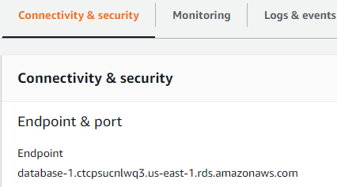

It should look like the following:

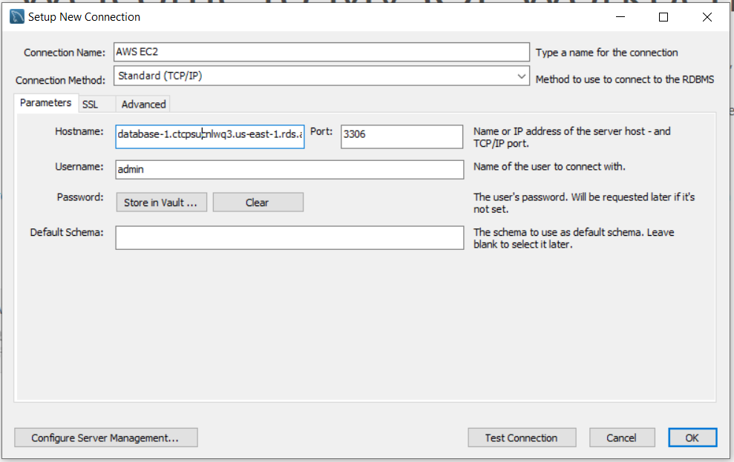

Step 6: Click on the “Test Connection” button, if there is no error you should be able to enter the new connection.

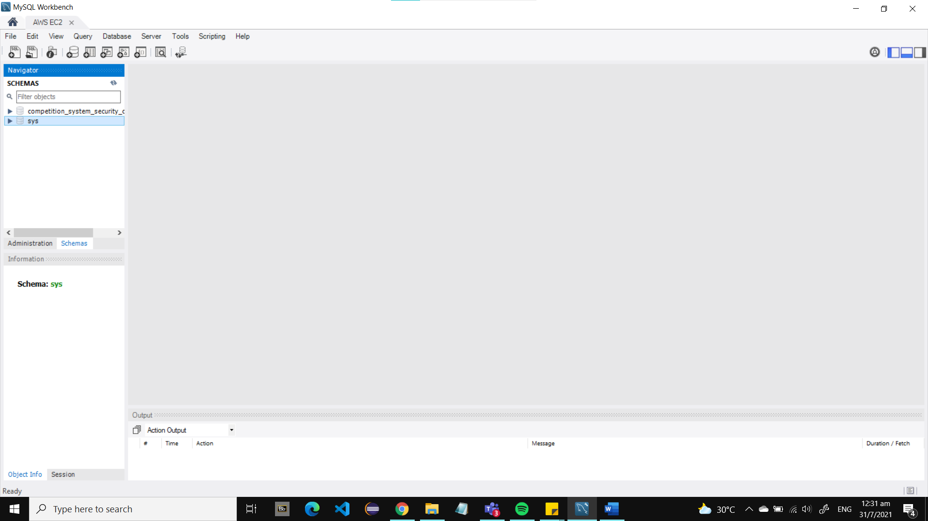

Step 7: Download the following database SQL text file containing all the data for the Bee Design website.

<https://drive.google.com/file/d/1vjs9yqzA4rfILu0Liv2mT0CRhLGPwMKE/view?usp=sharing>

Step 8: on the top menu, under “File”, click on “Open SQL Script” and load the downloaded file.

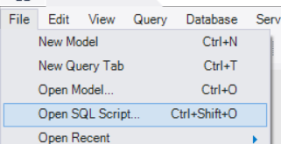

Step 9: Run the file by clicking on the lightning symbol.

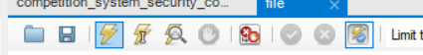

Step 10: If you get an error on granting permission to adminuser, run the following code:



GRANT ALL PRIVILEGES ON competition_system_security_concept_v2_db.* to 'adminuser'@'%';

Step 11: Go to the backend folder, into the database.js. Edit the host name to that of your AWS EC2 connection.

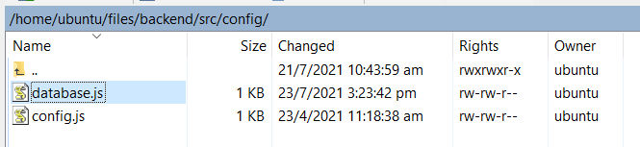

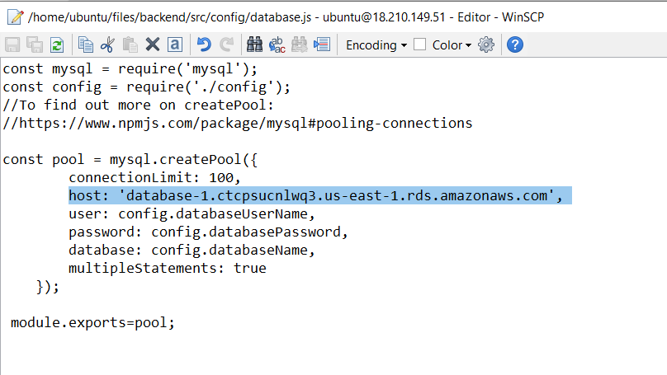

Step 12: Open up the PuTTYgen terminal for backend folder and run the following code:

Node seeddata.js

This will seed the data into the tables; file, user and role, under the competition_system_security_concept_v2_db database.

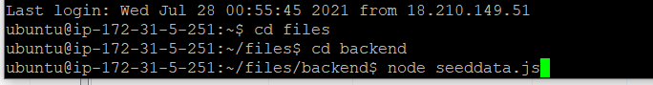

After a successful seeding, run the tables to check that the data has been injected.

Eg: file table

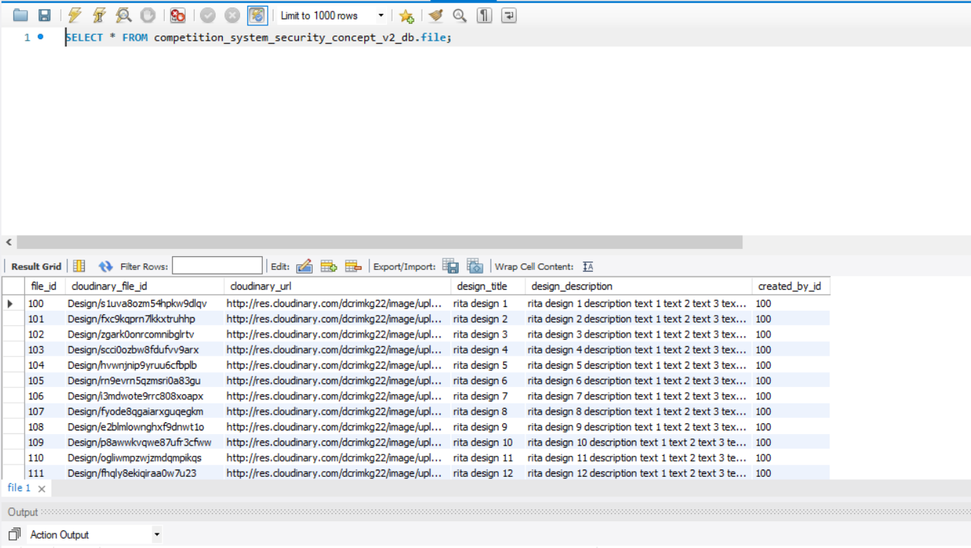

Step 13: Run both frontend and backend servers and try to login as user: [rita@designer.com](mailto:rita@designer.com) and password: password. If you successfully log in, you now have a working EC2 machine and RDS database.

### 3.3 Data Encryption of RDS Database

Step 1: to go the RDS page and under the side menu click on “Snapshots”.

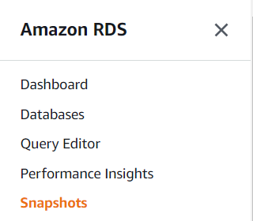

Step 2: Under the “Manual Snapshots” click on the “Take snapshots” button.

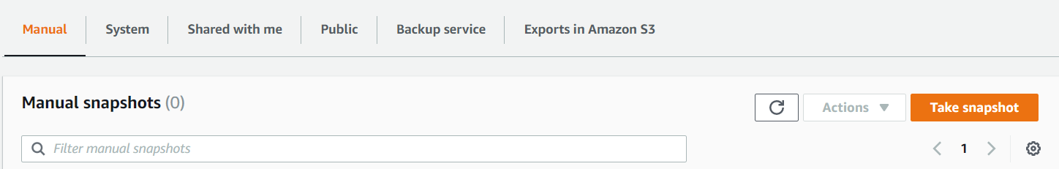

Step 3: Select the database you have created and put a name that will allow you to remember which version and database is it for.

Eg: Snapshot Name: esde_rdsDatabase1_snapshot1

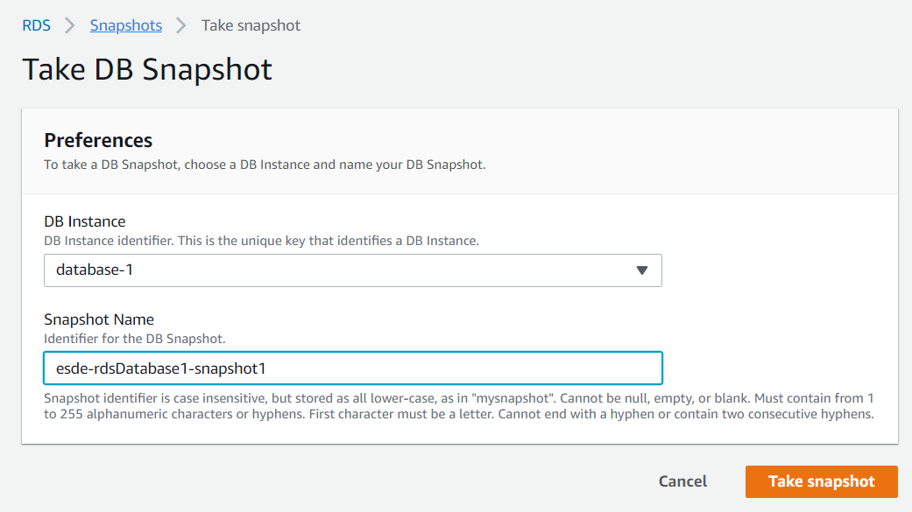

Step 4: Click on the “Take snapshot” button. Afterwards, click on the newly created snapshot and wait for the snapshot status to be “Available”.

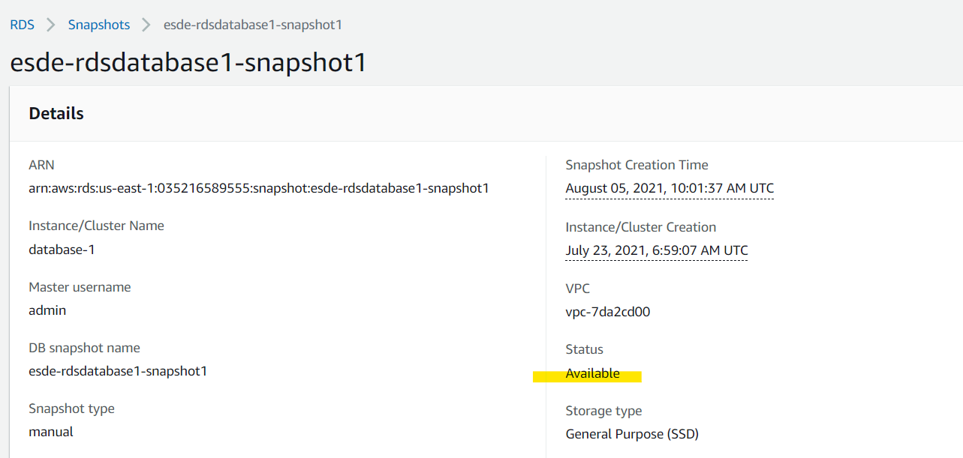

Step 5: Under the “Actions” click on the “Copy snapshot”.

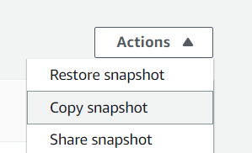

Step 6: For the snapshot settings: for the destination region leave it by default, eg: US East (N. Virginia), and put an identifier name to your preference, and leave the rest of the settings by default.

Eg: New DB Snapshot Identifier: esde-rdsDatabase1-copysnapshot1

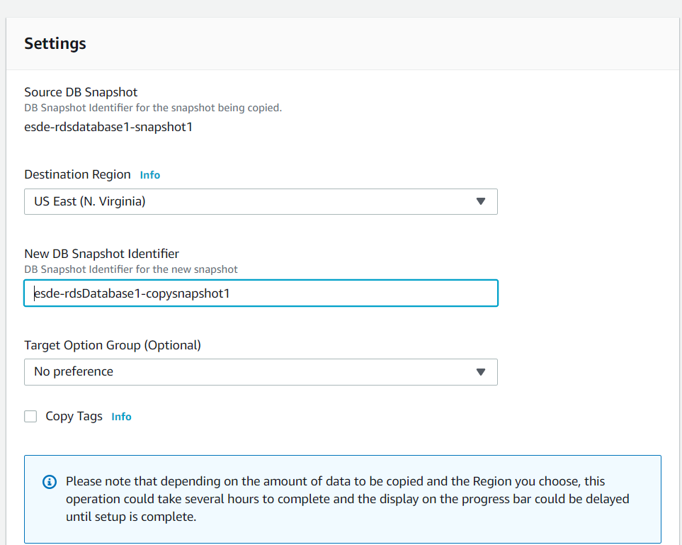

Step 7: Scroll down and check the “Enable Encryption” and leave the rest of the setting by default.

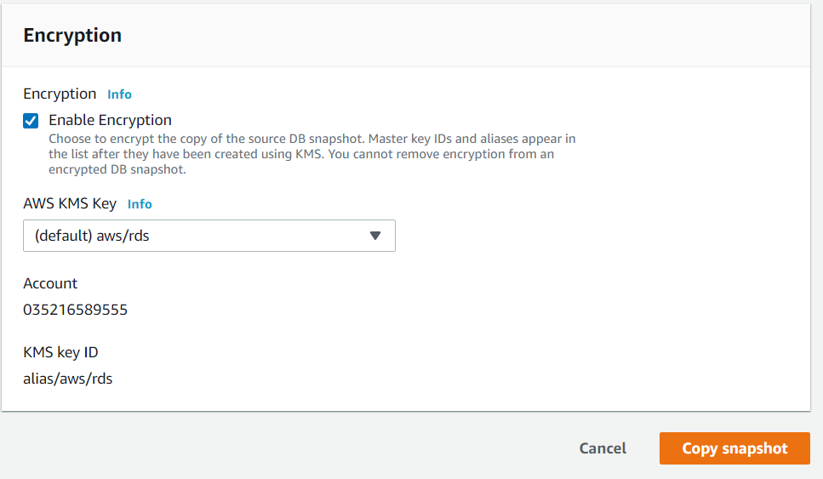

Step 8: Click on the “Copy snapshot” button and wait for the snapshot status to be “Available” and scroll to the right to check that the “Encrypted” field is “True”.

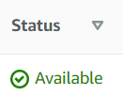 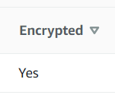

With this you have encrypted the RDS database you have created, and you can use this snapshot to restore the DB instance if you ever need to.

Step 9: Click on the copied snapshot and under action click on the “Restore snapshot” button

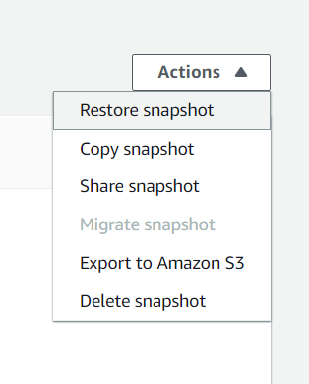

Step 10: For the new identifier put “encrypted-database” and leave the rest of the settings by default.

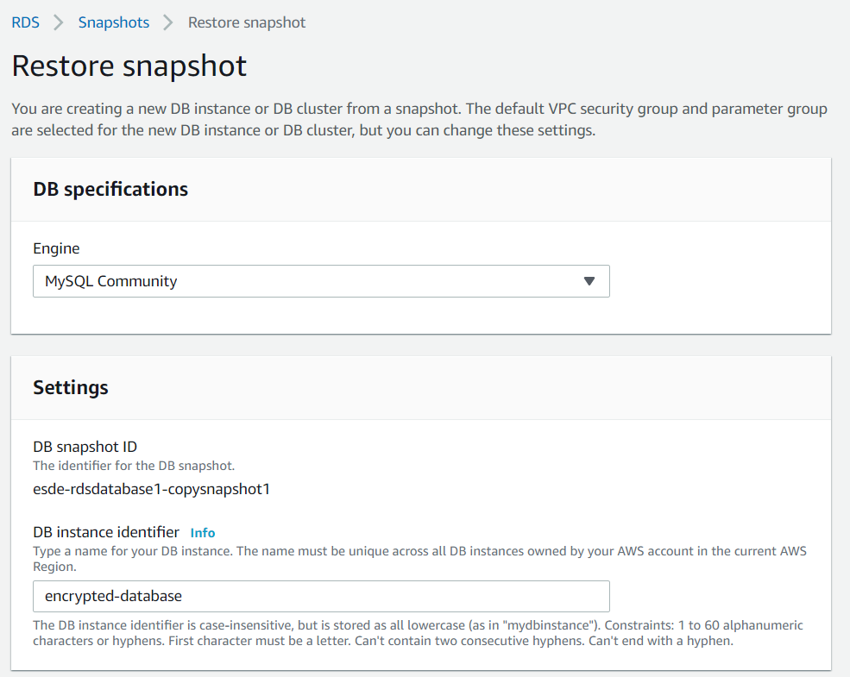

Step 11: Ensure that the encryption is enabled and click on the “Restore DB instance”.

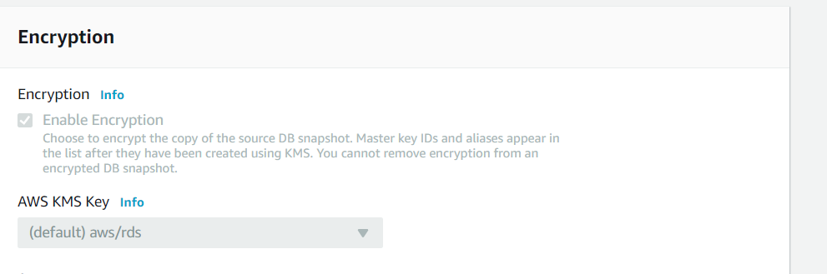

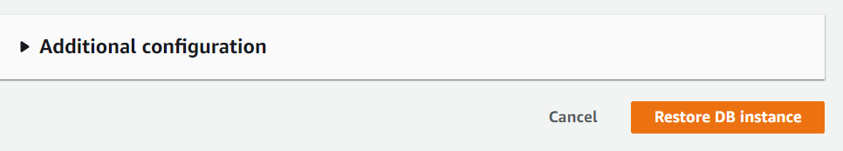

Step 12: When the DB instance has finished creating click on the instance and scroll down to Connectivity & Security. Copy the endpoint and paste in a notepad.

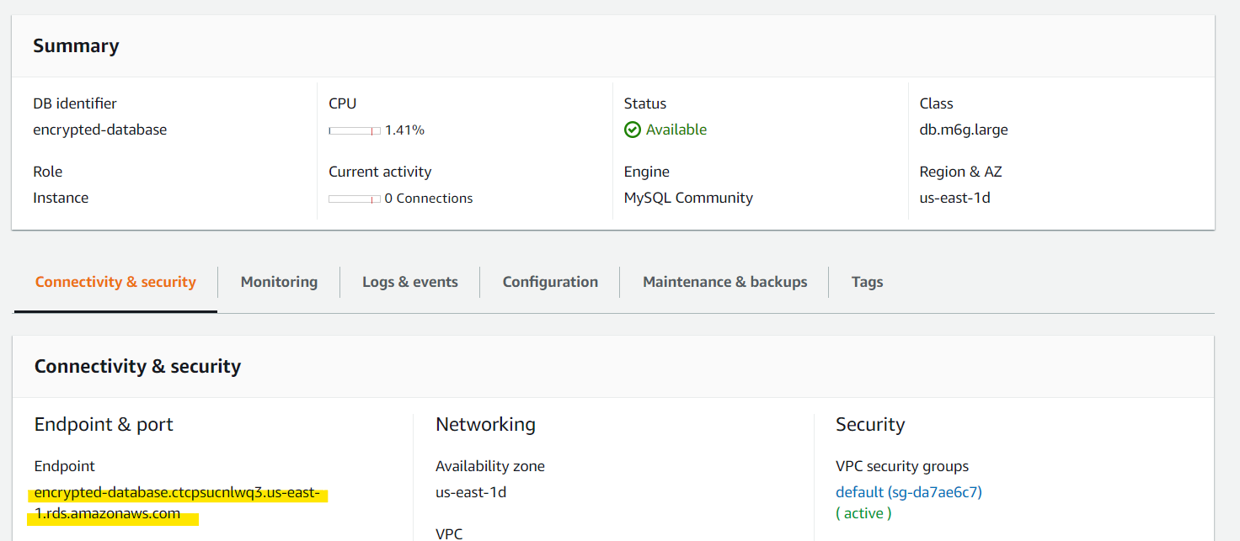

Step 13: Go to your WinSCP and open the database.js in the backend config folder and change the database endpoint in “host” to the endpoint you have copied in the previous step.

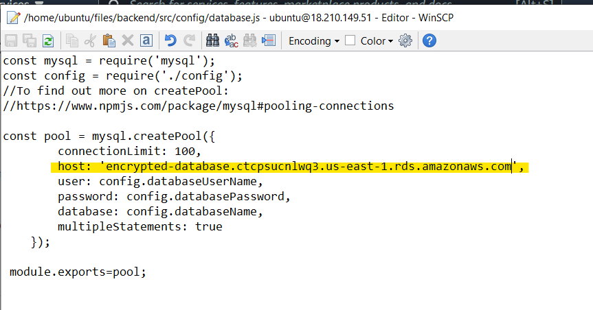

With this you now have an extra layer of protection for your database, and this will prevent unauthorized access to the underlying storage.

### 3.4 Database Logging

Step 1: On the RDS databases page select the encrypted database and click on the “Modify” button.

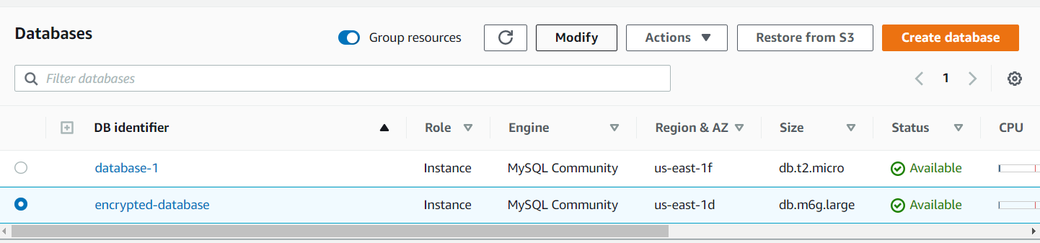

Step 2: Scroll down to “Additional configurations” and open it up.

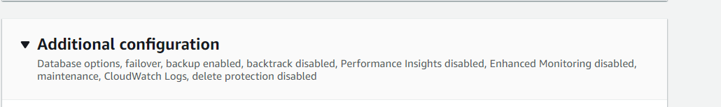

Step 3: Scroll down to “Log exports” and check all the boxes. Afterwards, click on the “Continue” button.

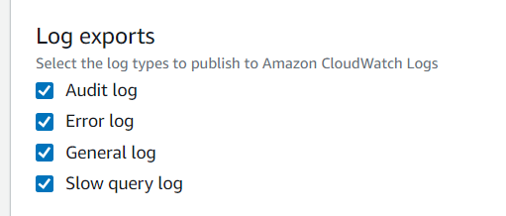

Step 4: Check that the changes being made is correct and select the “Apply immediately” button for “Scheduling of modifications” due to the rush for time.

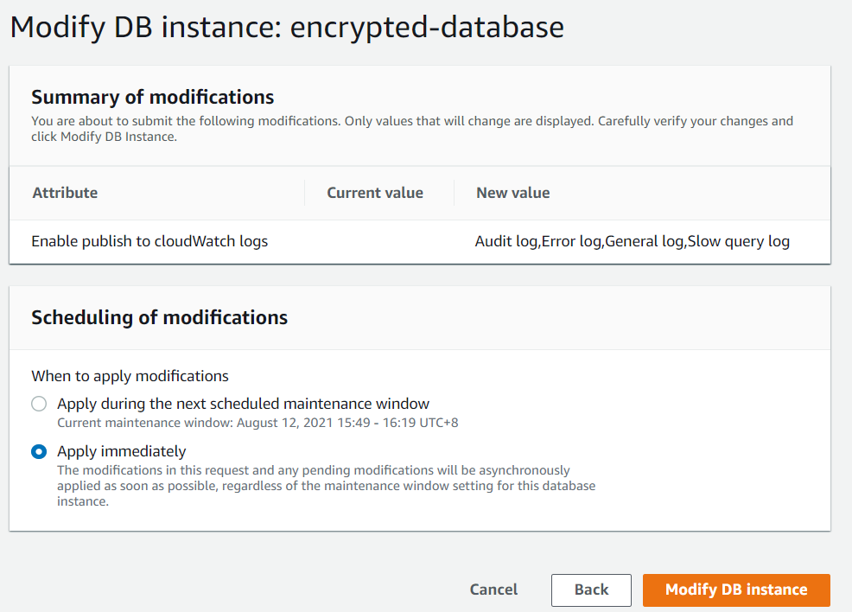

Step 5: Click on the “Modify DB instance” and with this you have enabled database logging.

### 3.6 Configuring User Privileges for the Database

Step 1: Go to your MYSQL workbench and on the topmost menu under “Server” click on “User and Privileges”

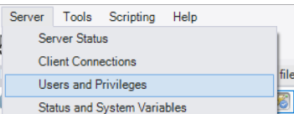

Step 2: Select “adminuser” and click on the privileges it currently has. Afterwards uncheck all of the DDL rights and click on the “Apply” button.

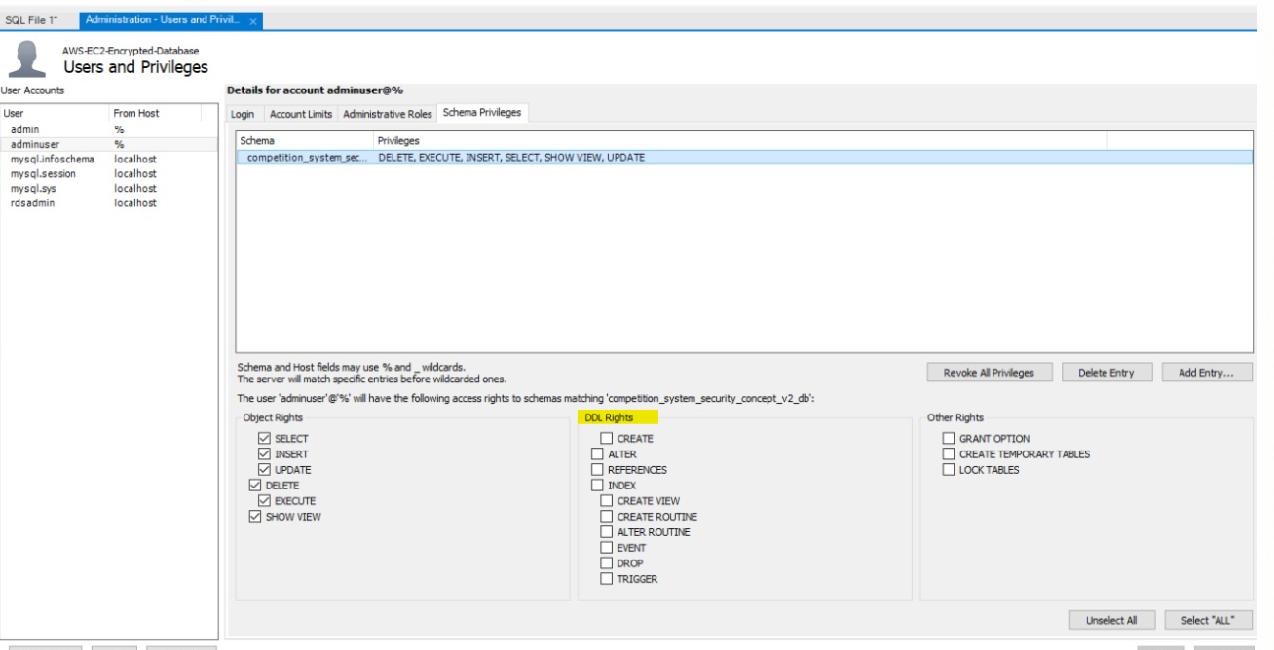

With this you have applied the least privileges for the “adminuser” and this will ensure that only the EC2 instance running the NODEJS code will have access to the RDS database.

## **4 Creating a DynamoDB Table**

DynamoDB is a serverless database that has no rows and columns freely allowing the storage of JSON documents or key value pairs and is typically hosted in a distributed computing environment for fault tolerance and redundancy. We will be creating a DynamoDB in the creation of a serverless API for one of the Bee Design website functions, updating file submissions.

### 4.1 Creating a Cloud9 Environment

Step 1: In the search bar of your AWS account, search “cloud9” and click on the following:

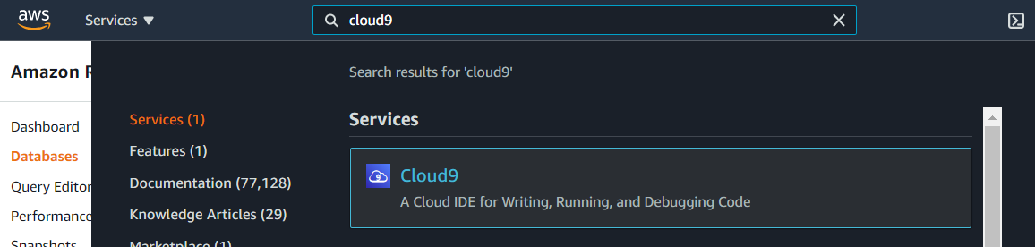

Step 2: Click on “Create environment”.

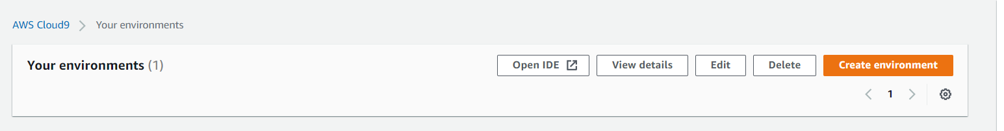

Step 3: name your environment such that you can know what it is for. The description can be left blank. Click on the “Next step” button.

Eg: ESDE-Assignment

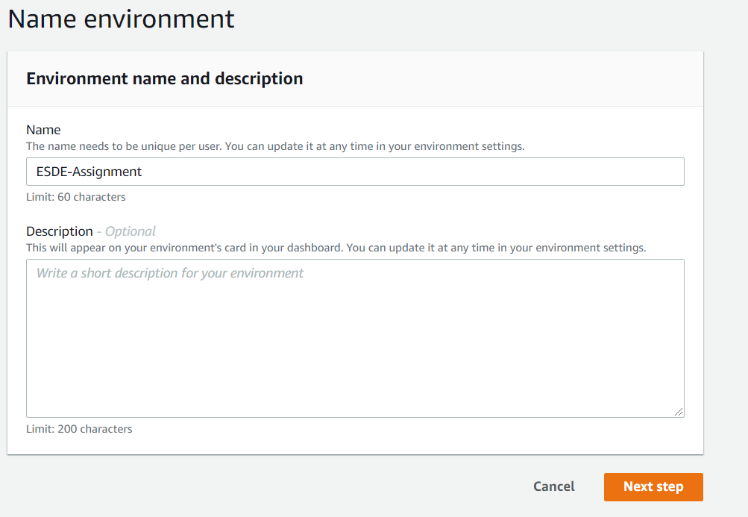

Step 4: Select the following for environment settings: Environment Type : Create a new EC2 instance for environment (direct access) , Instance type : t2 micro (1 GD RAM + 1 vCpu).

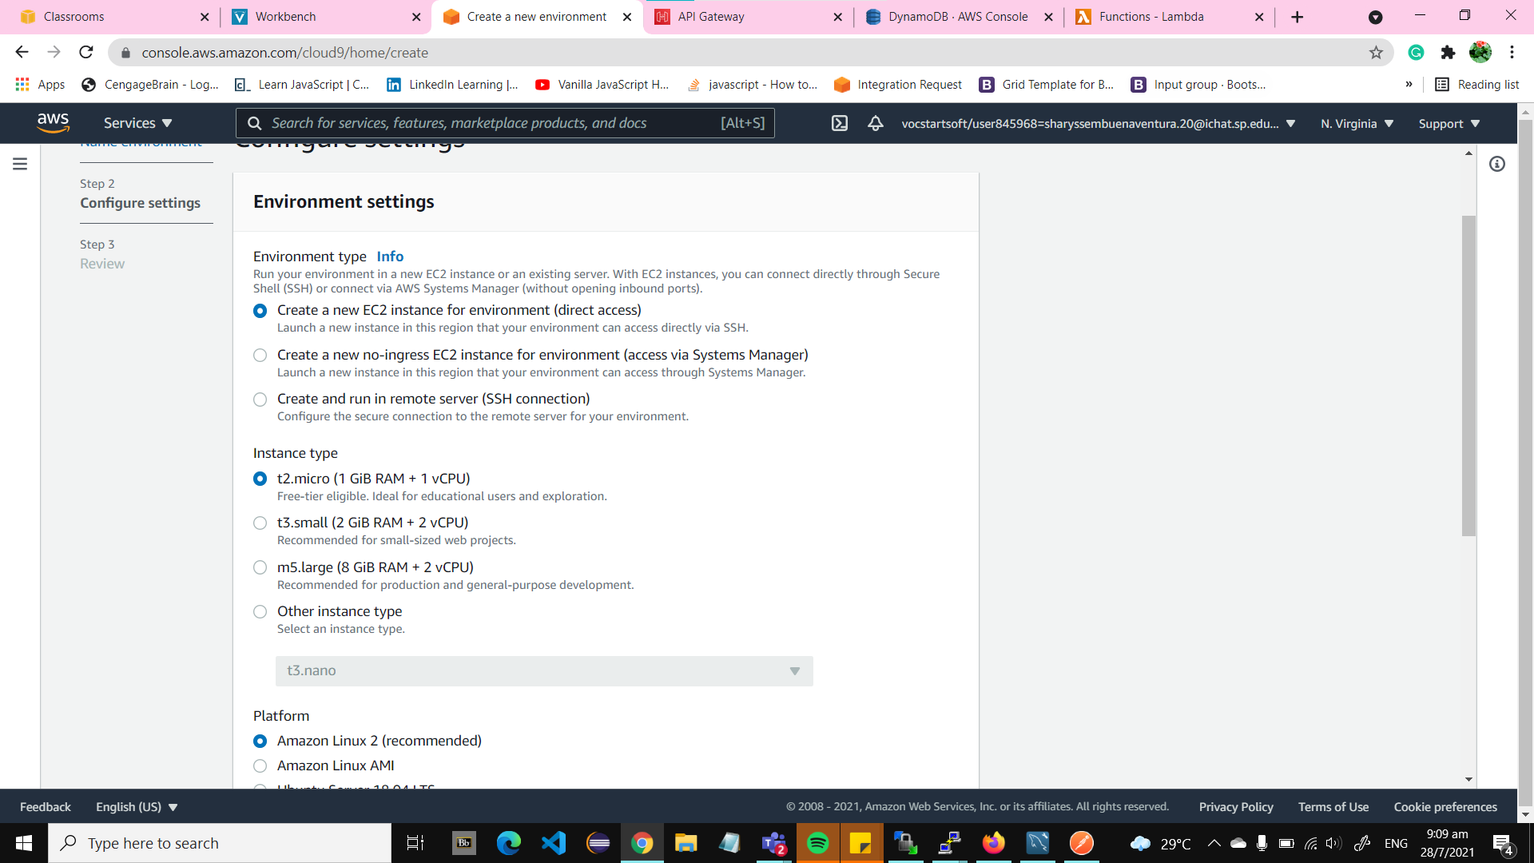

As for the platform and cost-saving settings, leave it by default. Click on the “Next step” button.

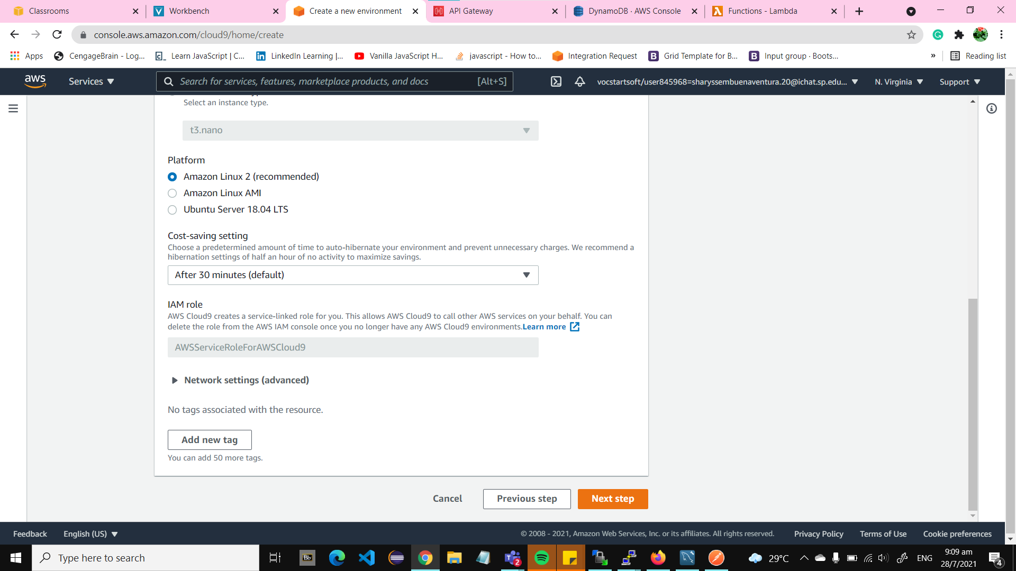

Step 5: Check that all the settings are correct and click on the “Create Environment” button.

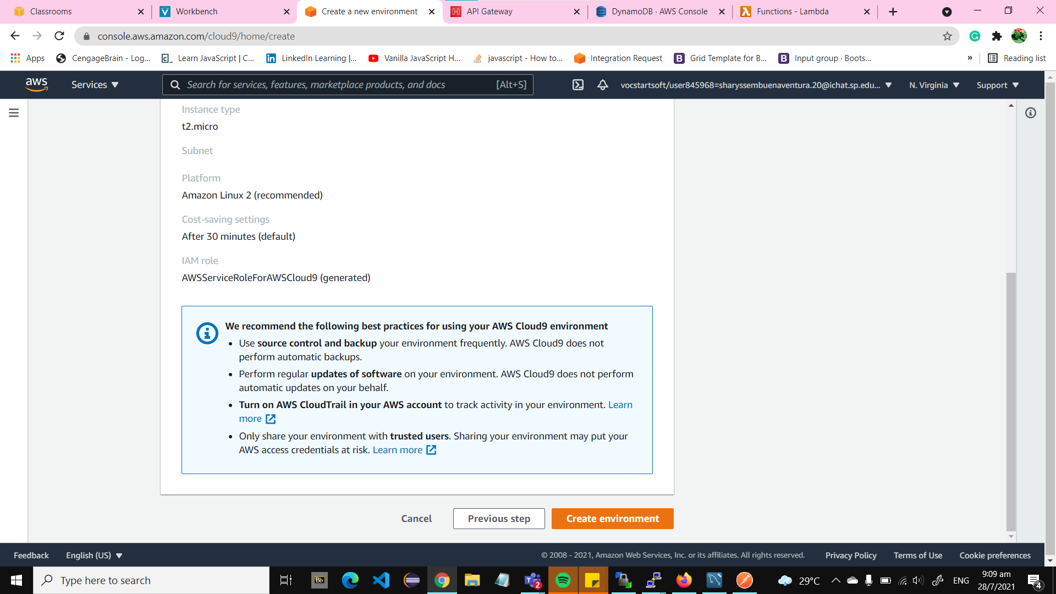

It should be loading like the following:

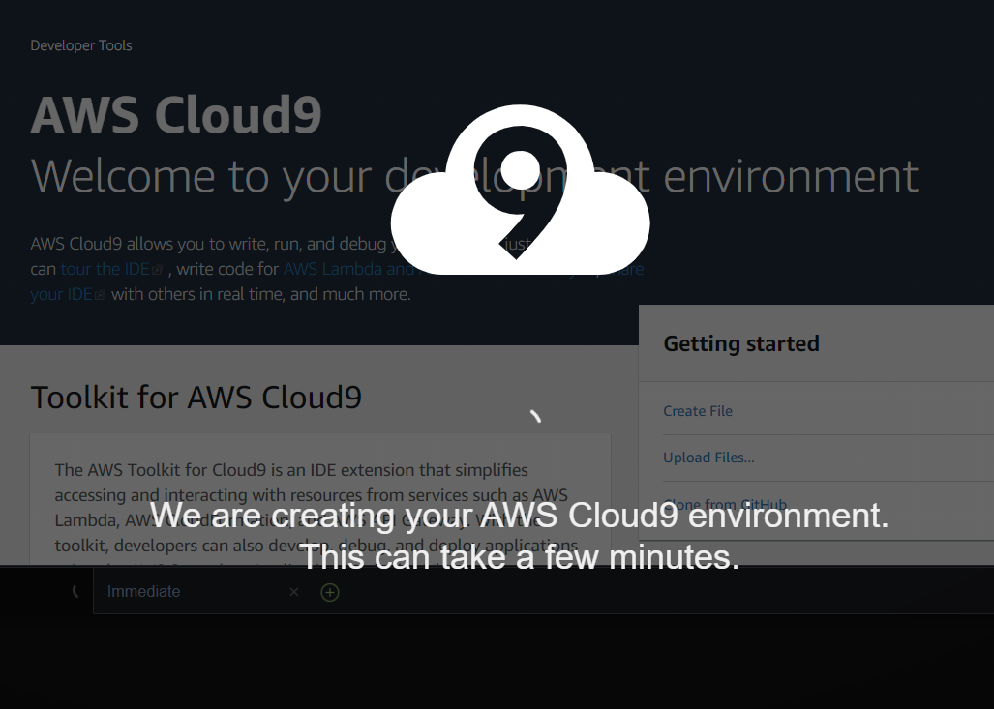

Step 6: Once the Cloud9 environment has been created, in the terminal run the following code to install aws-sdk which is a collection of software tools for AWS that we will be using to create a serverless API.

Npm install aws-sdk

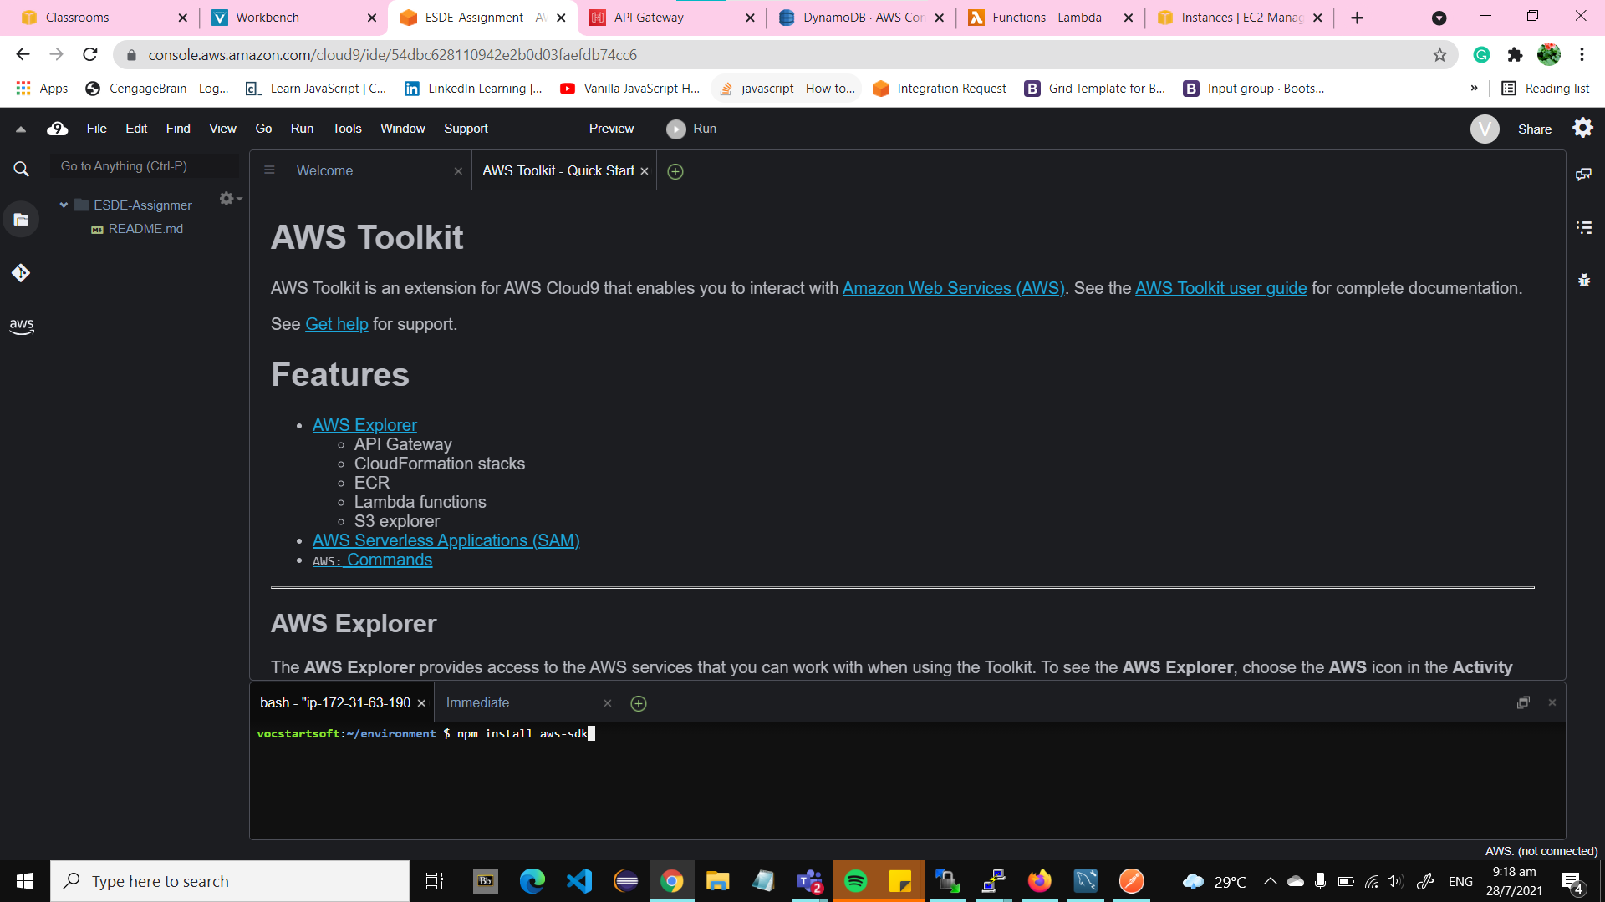

### 4.2 Create a DynamoDB table

Step 1: In the search bar of your AWS, search “dynamodb” and click on the following:

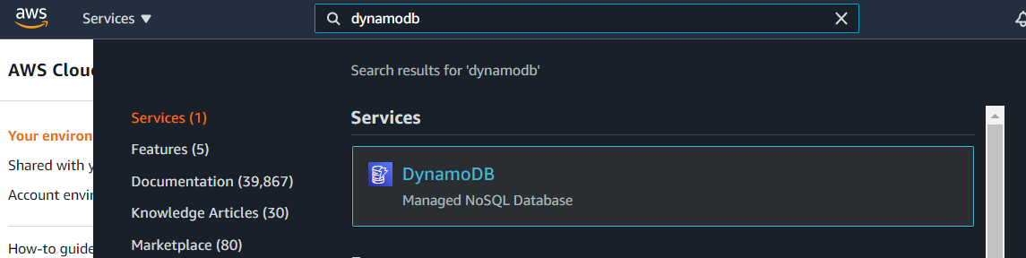

Step 2: In the side menu click on the “Tables” or press the “Create table in the main page.

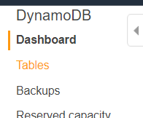

OR

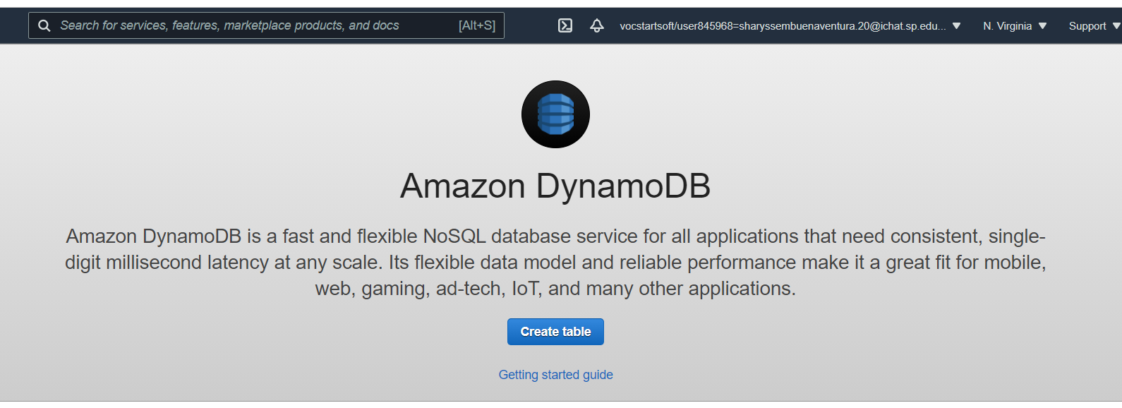

Step 3: For the settings of the table put Table name: files, Primary key : file_id, and leave the table settings by default.

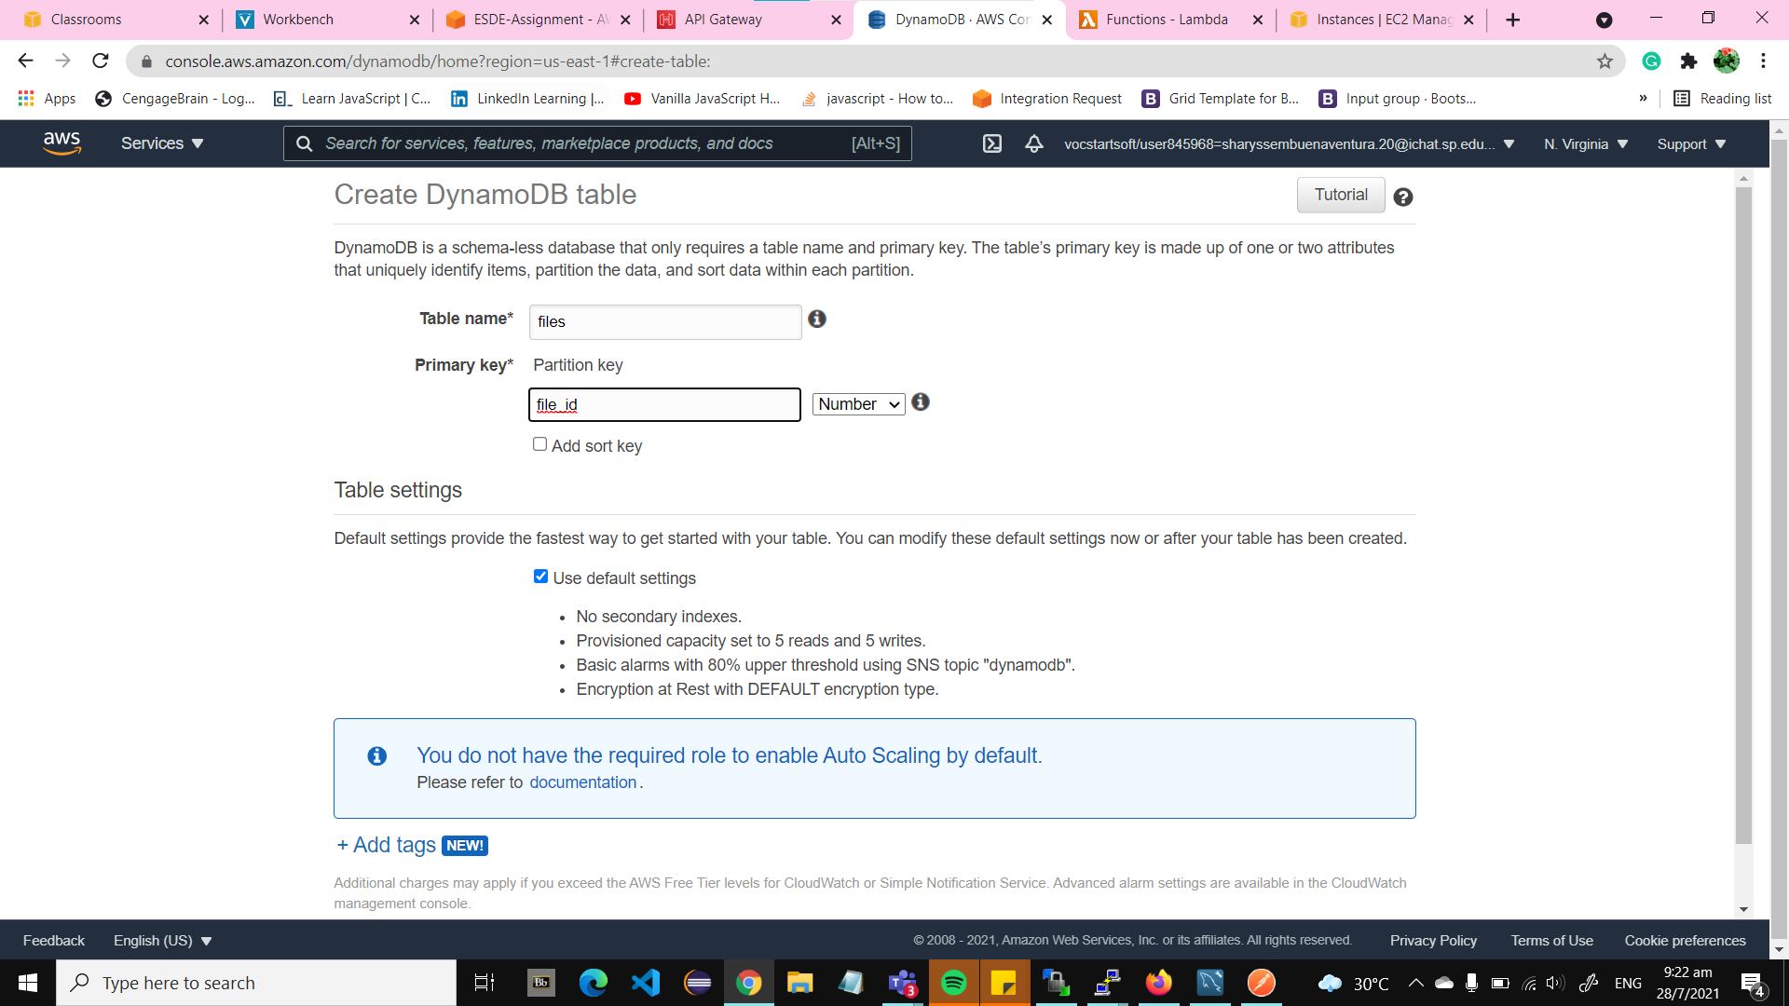

Step 4: Click on the “Create” button, afterwards you should be able to see the table “files”. Click on the “files” table.

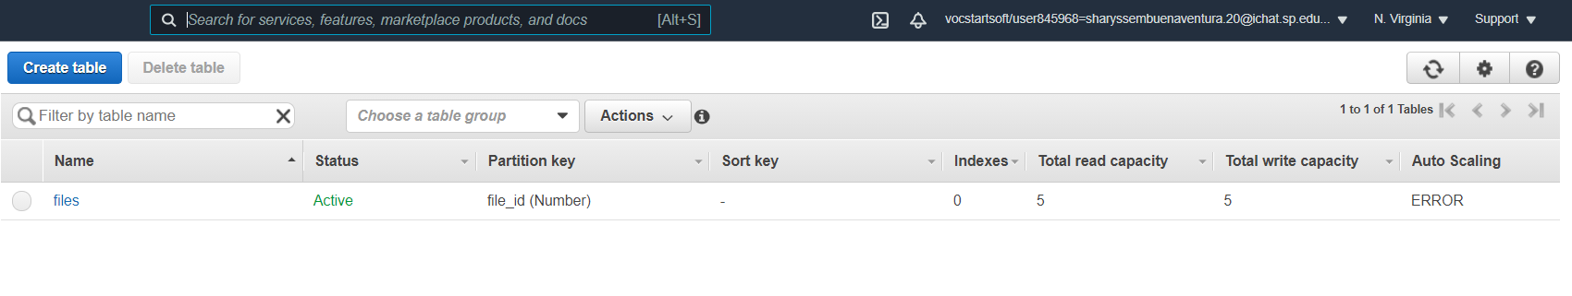

Upon clicking on the table, you will see that the table is empty as we have not imported the data from the MYSQL workbench database.

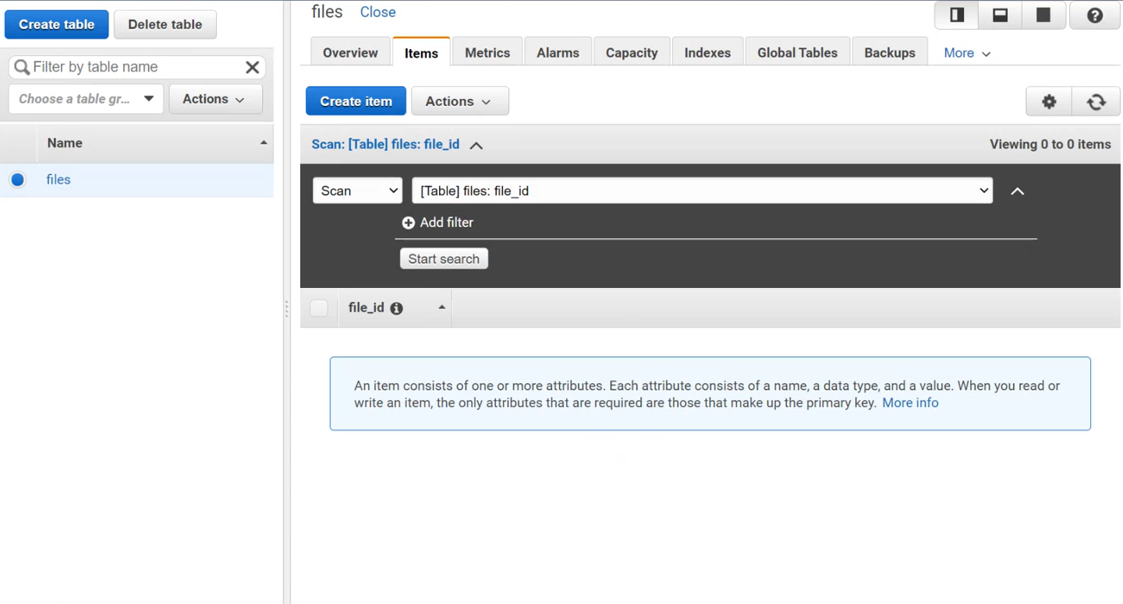

### 4.3 Importing Data into DynamoDB

Step 1: Go to your MYSQL workbench EC2 AWS connection, right-click on the “file” table and click on the “Table Data Export Wizard”.

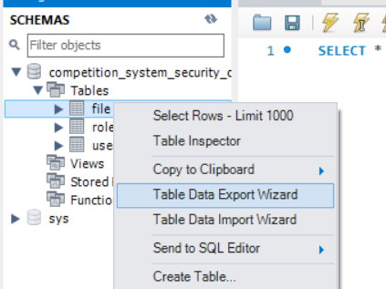

Ensure that all the rows of the “table” are selected and click on the “Next” button

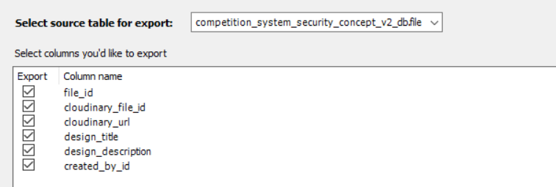

Step 2: Select the “json” option and browse to your preferred file path and file name. Ensure that the file is saved as “Javascript Object Notation (*.json)”.

Eg: file.json

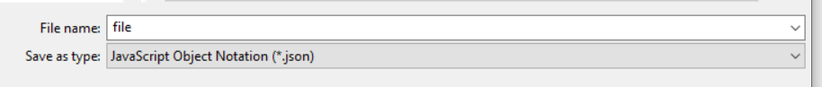

Step 7: Click on the “Next” button until you reach the “finished” page. This indicates that the file has been successfully exported.

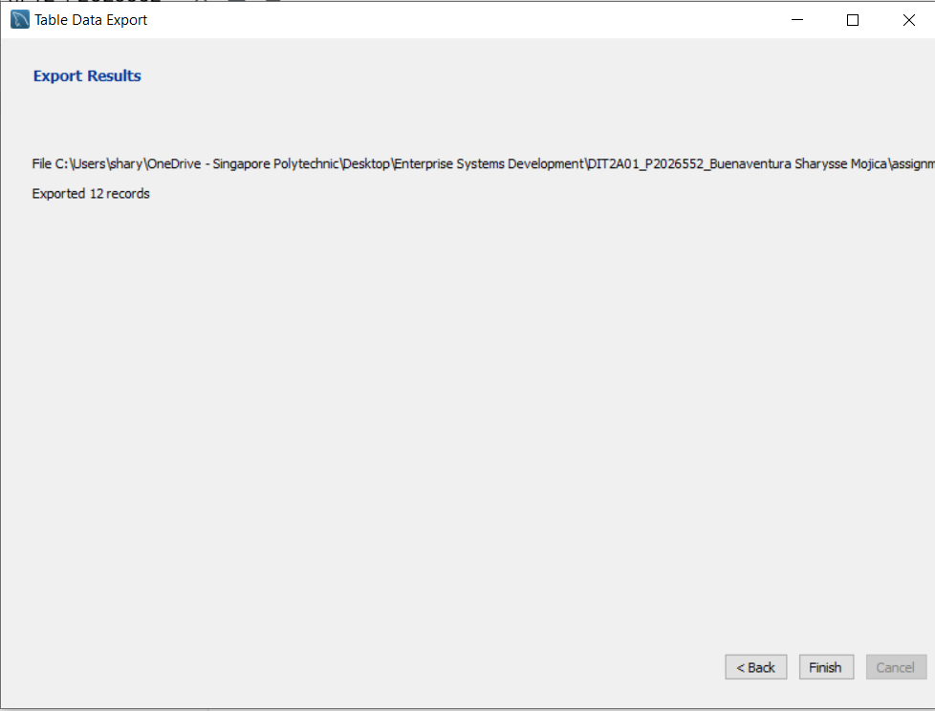

Step 8: Go to your Cloud9 environment and click on “Upload Local Files…” under the “file” menu. Upload the “file.json” we have created in the previous step.

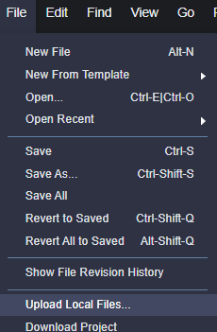

Step 9: Create a new file in which we will be seeding the database into the dynamoDB file table. You can name it such that you know what the file is for.

Eg: seed_file_db.js

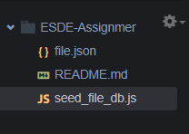

Step 10: Copy and paste the following codes into the seed_file_db.js and save the file. These codes will allow the data stored in file.json to be imported into the dynamoDB file table when run.

|  |
| --- |
| var  AWS = require("aws-sdk"),  DDB = new AWS.DynamoDB({  apiVersion: "2012-08-10",  region: "us-east-1"  }),  file_DATA_ARR = require("./file.json");  function addNewItemsFromJSON(){  console.log("All items now removed, re-seeding now");  var  file = {},  file_formatted_arr = [],  params = {};  for(var i_int = 0; i_int < file_DATA_ARR.length; i_int += 1){  file = {  PutRequest: {  Item: {  file_id: {  "N": file_DATA_ARR[i_int].file_id.toString()  },  cloudinary_file_id: {  "S": file_DATA_ARR[i_int].cloudinary_file_id  },  cloudinary_url: {  "S": file_DATA_ARR[i_int].cloudinary_url  },  design_title: {  "S": file_DATA_ARR[i_int].design_title  },  design_description: {  "S": file_DATA_ARR[i_int].design_description  },  created_by_id: {  "N": file_DATA_ARR[i_int].created_by_id.toString()  }  }  }  };  file_formatted_arr.push(file);  }  params = {  RequestItems: {  "files": file_formatted_arr.reverse()  }  };  DDB.batchWriteItem(params, function(err, data){  if(err){  throw err;  }  console.log("OK");  });  }  (function init(){  addNewItemsFromJSON();  })(); |

Step 11: Click on the “Run” button for the seed_file_db.js to allow for the database seeding to occur.

Afterwards go to your DynamoDB file table and click on the refresh button. You should be able to see all the files data from your MYSQL workbench. With this you have successfully imported data into your DynamoDB file table.

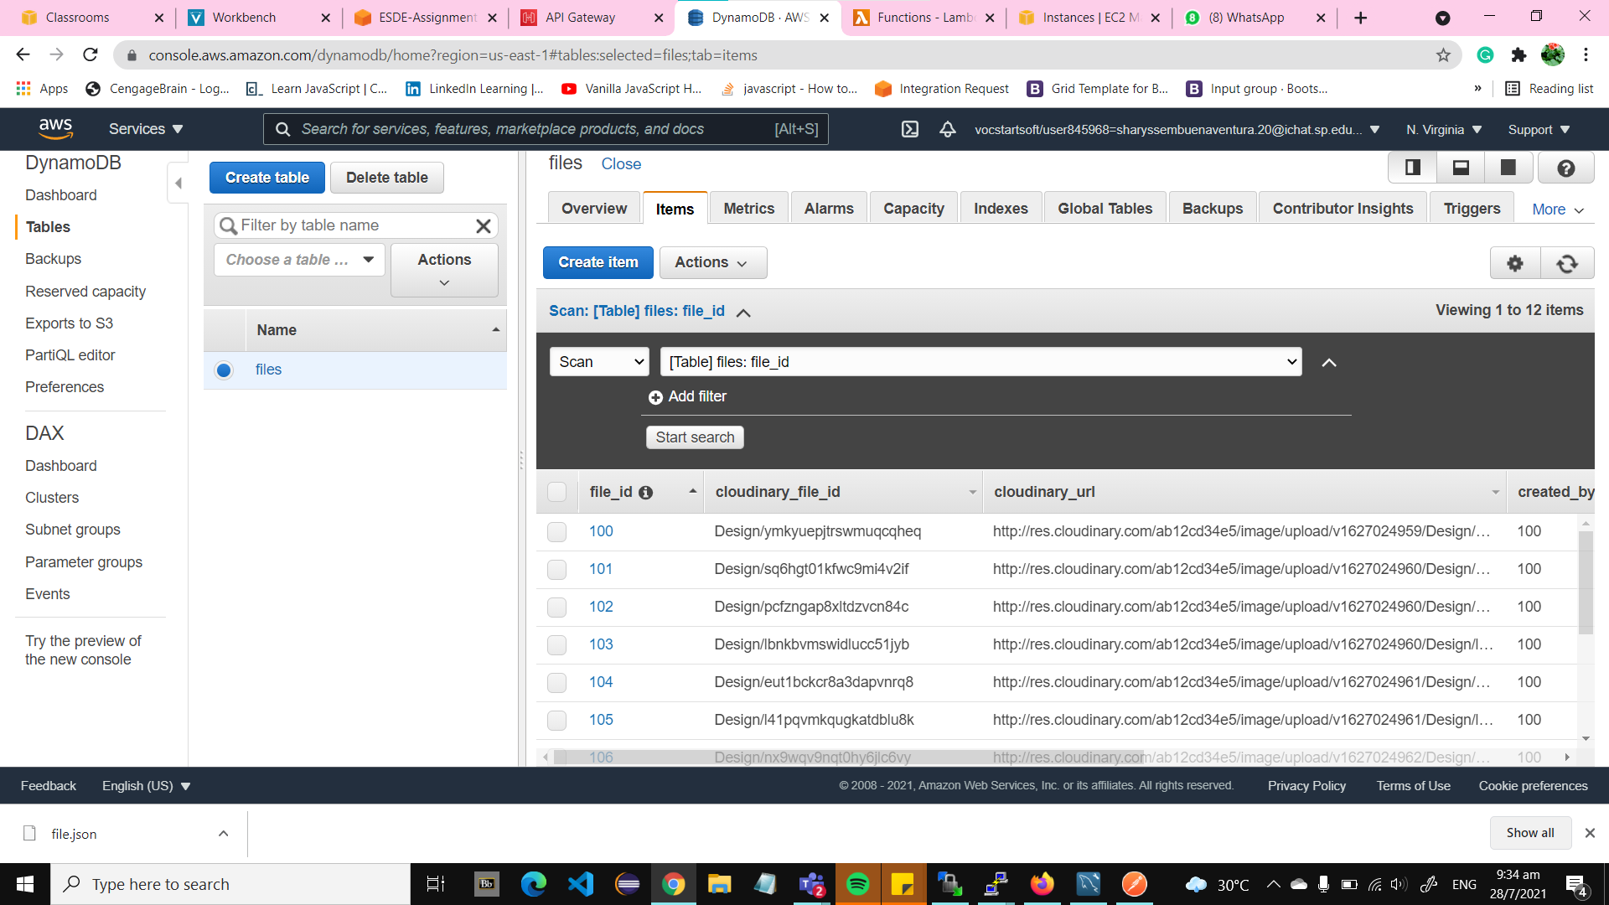

You can now see the submission files in the Bee Design Website

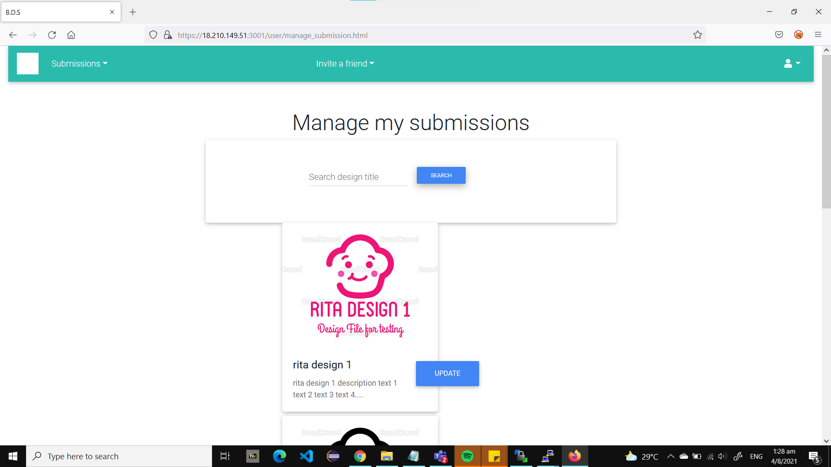

## **5 Creating a Lambda Function**

Lambda is a serverless compute service that enables virtual running of any backend services or application without any administration. It is a service that automatically and accurately allocates compute execution power and runs codes based on the incoming request or event for any scale of traffic. We will be creating a function to allow the updating of submission in the Bee Design website without a server.

### 5.1 Creating a Lambda Function

Step 1: In the search bar of your AWS account search “lambda” and click on the following:

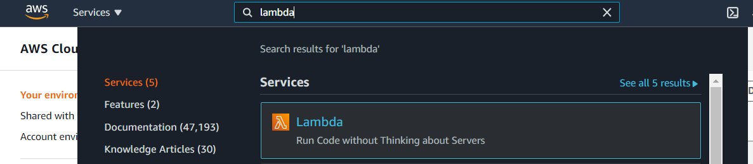

Step 2: Click on the “Create function” button:

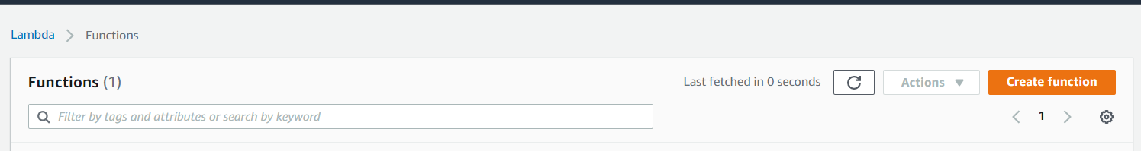

Step 3: For the lambda function settings leave the create function by default. Choose a Function name that states its function and leave the runtime and permissions by default.

Eg: esde_beedesign_getDesginById

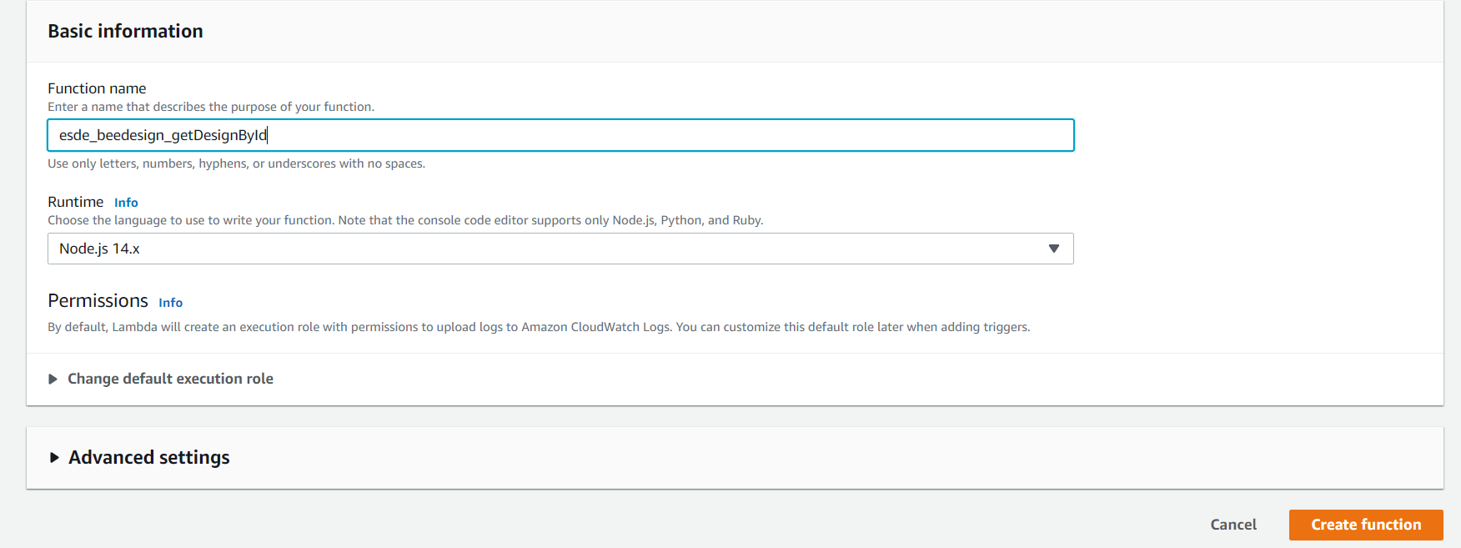

Step 3: Click on the “Create function” button. You will be redirected to the function you have just created. With this you have successfully created a lambda function.

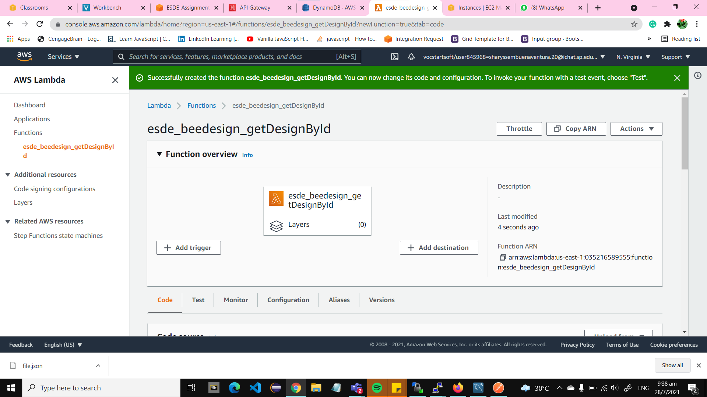

### 5.2 Configuring Lambda Role Permissions

Step 1: Scroll down the function and click on “Permissions” under “Configurations”. Click on the “Role name”. You will be redirected to Identity and Access Management (IAM) of the role.

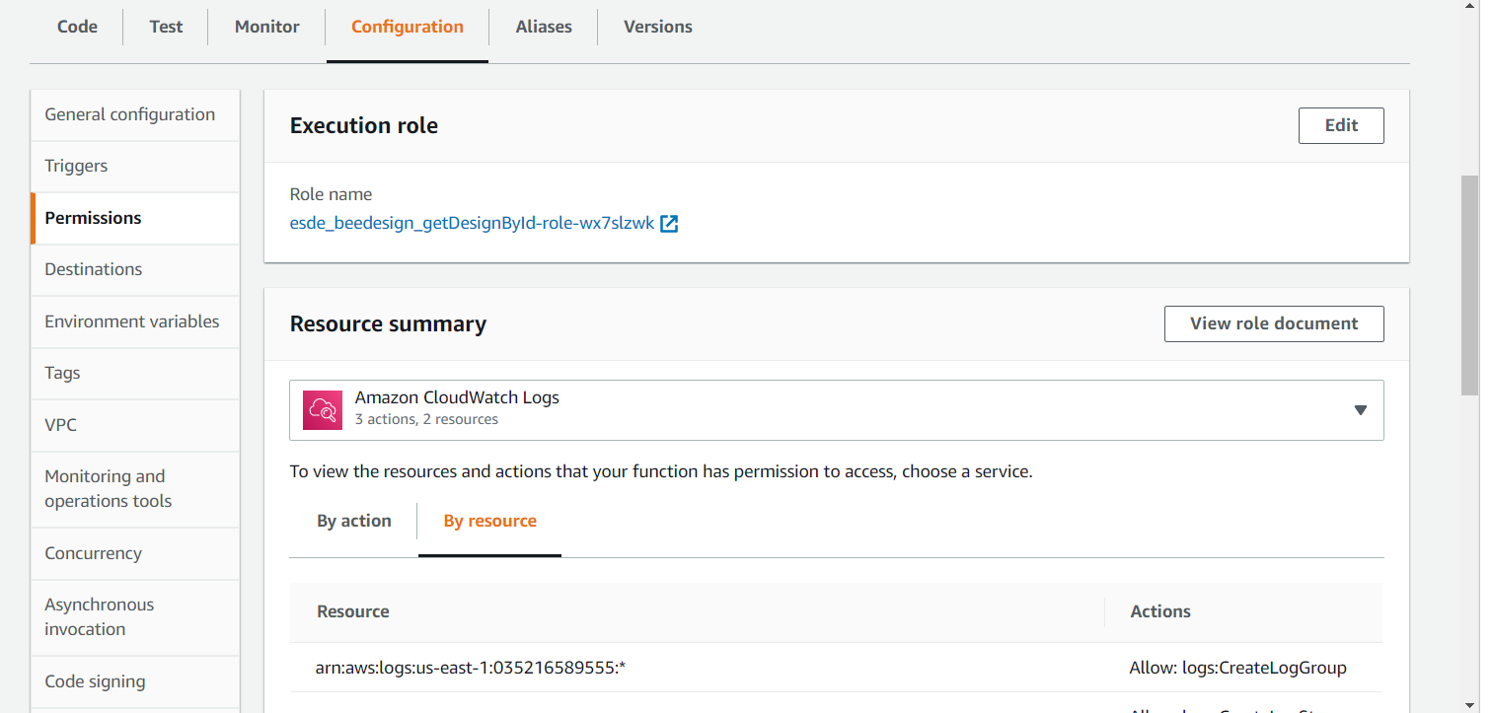

Step 2: You will need to copy the Role ARN and store in a notepad or leave this browsing tab open for the upcoming steps. Afterwards scroll down to “Permissions” and click on the “Attach policies” button.

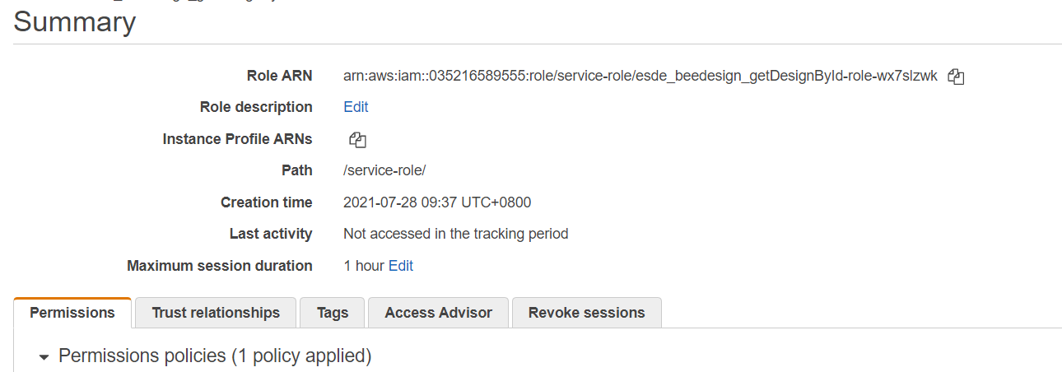

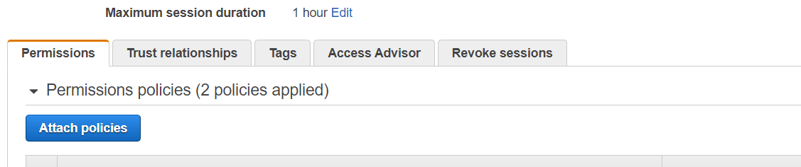

Step 3: Search for “amazondynamodb” and select the following policy.

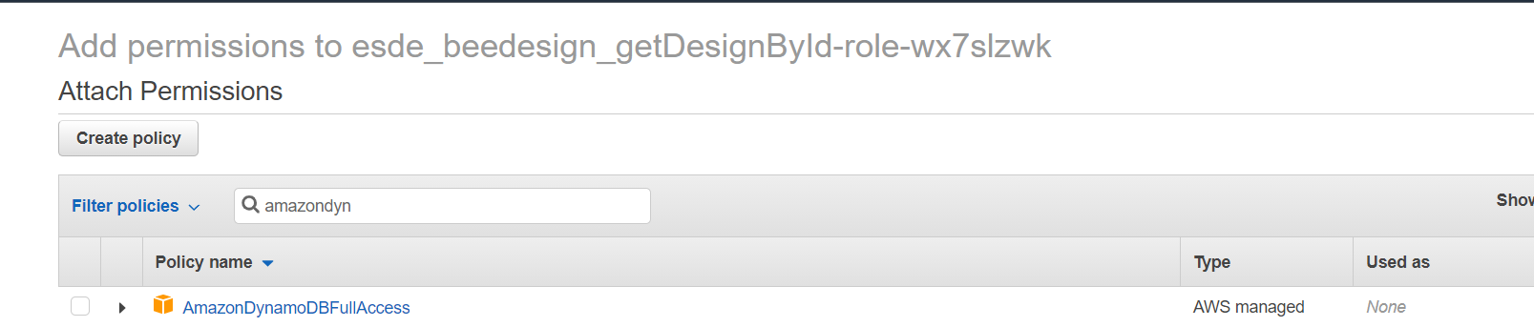

Step 4: Search for “lambda” and select the following policy.

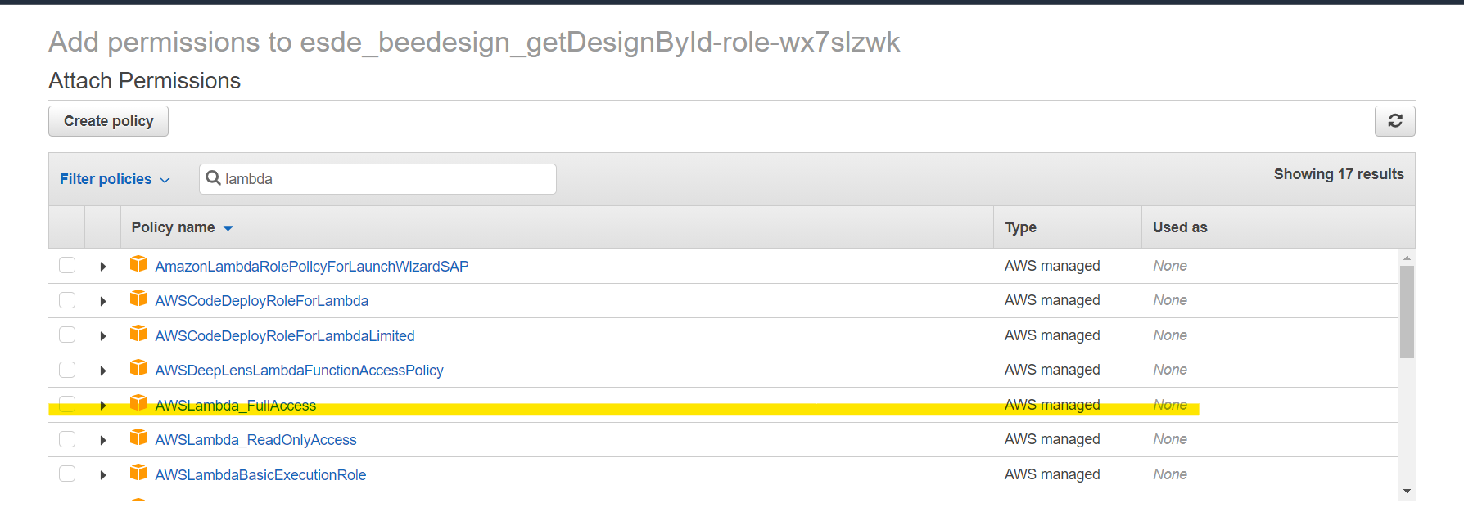

Step 5: Search for “apigateway” and select the following policy. We will be adding this policy now to prevent any confusion and the possibility of forgetting to do this step later on

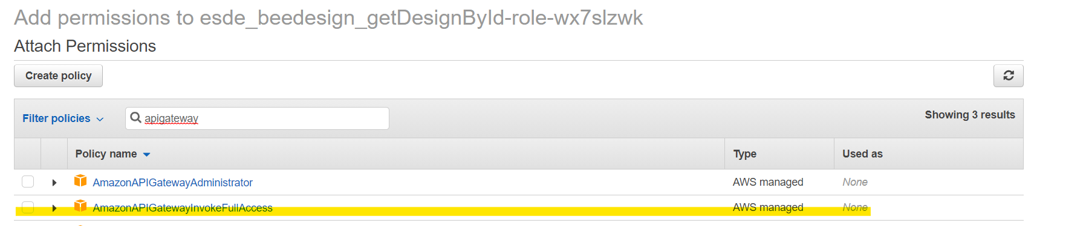

Step 6: Click on the “Attach policy” button and you should have the following permissions policies applied:

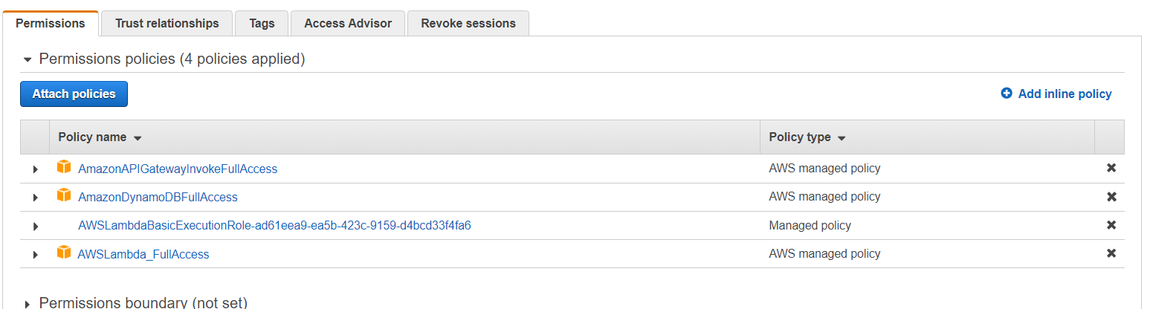

Step 7: Click on the “Edit trust relationships” button under “Trust relationships”

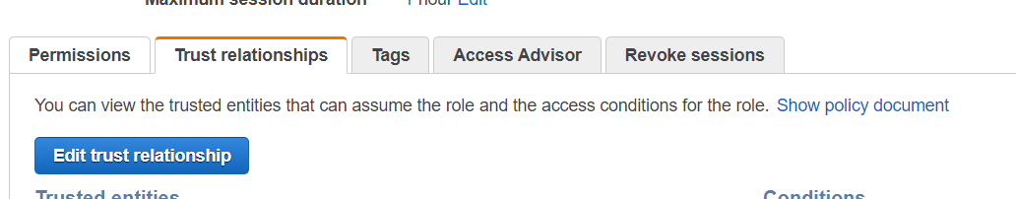

Step 8: Under Principal and service add the following codes:

“dynamodb.amazonaws.com”, “apigateway.amazonaws,com”

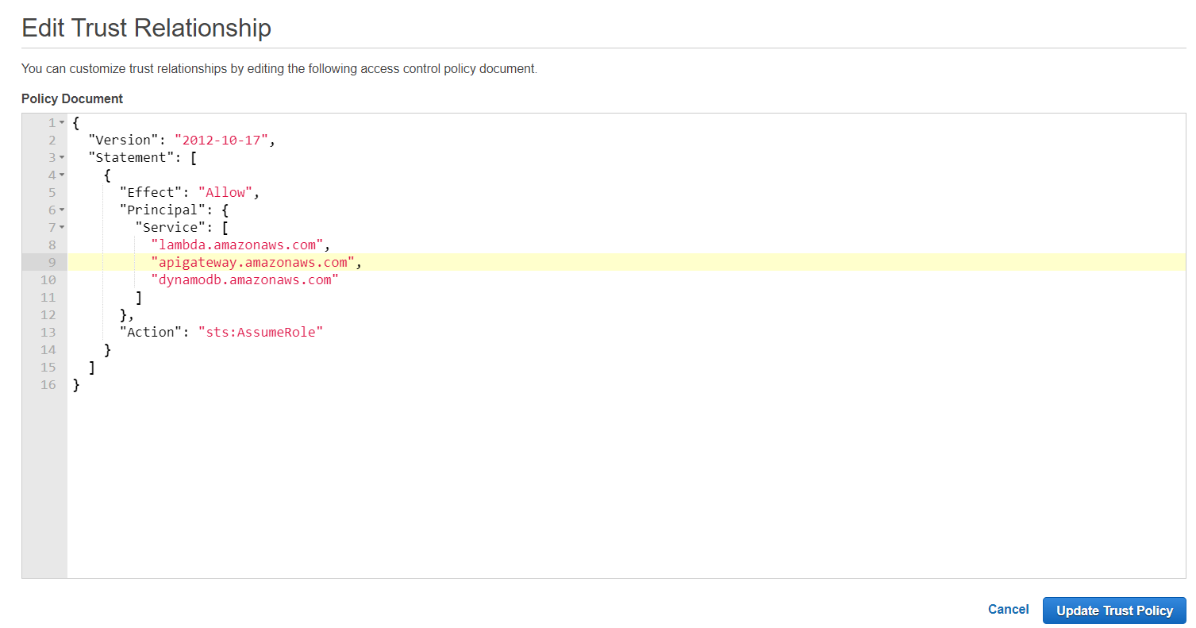

Step 9: Click on the “Update Trust Policy” button. With this you have successfully added permissions to the lambda role for “esde_beedesign_getDesignById”.

### 5.3 Creating a Lambda Query

Step 1: Go to your API gateway, scroll down and click on the “Code” on the menu. Where you will see a main folder “esde_beedesign_getDesignById” and an index.js file.

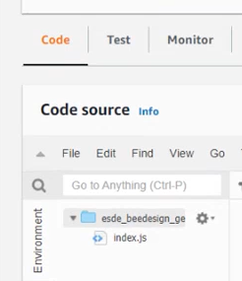

Step 2: Create a new folder under “esde_beedesign_getDesignById” and name it “dynamodb”. Afterwards, create a new file and name it “query_dynamo.js”. It should look like the following:

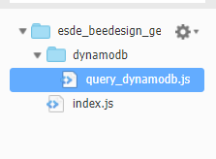

Step 3: Click on the index.js and delete all of the codes as we will be inserting codes that will check whether or not data is fetched from the DynamoDB file table, if it is the correct data and send the data and request response back to the client side of the server.

Copy and paste the following codes into index.js and save the file.

|  |
| --- |
| var dynamodbQuery = require('dynamodb/query_dynamodb');  exports.handler = async function(event, context, callback){  if (event.fid|| (event.queryStringParameters && event.queryStringParameters.fid)) {  if (event.fid)  var fileId = parseInt(event.fid);  else  var fileId= parseInt(event.queryStringParameters.fid);  var region = "us-east-1"  var table_name = "files"  var expr_attr_values = { ":fileid": fileId }  var key_cond_expr = "file_id=:fileid"  var proj_expr = "file_id,cloudinary_url,design_title,design_description"  await dynamodbQuery(region, table_name,expr_attr_values,key_cond_expr,proj_expr)  .then(data => {  console.log("Successfully got items from dynamodb.query")  var responseCode = 200;  var jsonResult = {'filedata': data.Items[0]}  let response = {  statusCode: responseCode,  body: JSON.stringify(jsonResult),  headers: {  "Access-Control-Allow-Headers" : "Content-Type,user",  "Access-Control-Allow-Origin": "*",  "Access-Control-Allow-Methods": "OPTIONS,POST,GET"  }  }  console.log("response: " + JSON.stringify(response))  callback(null, response);  })  .catch(error => {  console.log('There has been a problem with your fetch operation: ' + error.message);  var responseCode = 500;  let response = {  statusCode: responseCode,  body: JSON.stringify(error)  } |

Step 4: Go to the query_dynamodb.js, copy and paste the following codes and save the file. These codes will try to fetch the data from the DynamoDB file table, store the fetched data in an array and send the data or error if no data is fetched to the index.js.

|  |
| --- |
| var AWS = require('aws-sdk');  async function queryitems_dynamodb(region, table_name,expr_attr_values,key_cond_expr,proj_expr) {  console.log("In the queryitems_dynamodb method...")  var dynamodb = new AWS.DynamoDB.DocumentClient({region: region});  try{  var params = { TableName: table_name,  ExpressionAttributeValues: expr_attr_values,  KeyConditionExpression: key_cond_expr ,  ProjectionExpression: proj_expr}  var items = []    const results = await dynamodb.query(params).promise()  console.log("Printing results from queryitems_dynamodb " + results)  return results;      }  catch(tryerror) {  console.log("Error occurred in dynamodb.query..")  console.log(tryerror, tryerror.stack); // an error occurred  }  } //end function  module.exports = queryitems_dynamodb |

Step 5: Save the files and click on the “Deploy” button for both files to post the changes made into the lambda function.

The following image shows that before and after all changes have been posted into the function.

Before: After:

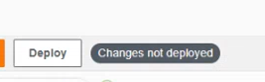 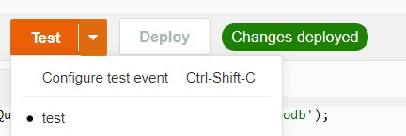

Step 6: Click on the down “Test” button and click on “Configure test event”. This is to test that our lambda function works and is retrieving data from the dynamoDB table.



Step 7: Select “Create new test event” and select “test” for Event template. Name the event “ test” and insert the following code:

{

“fid”: “100”

}

It should look the following:

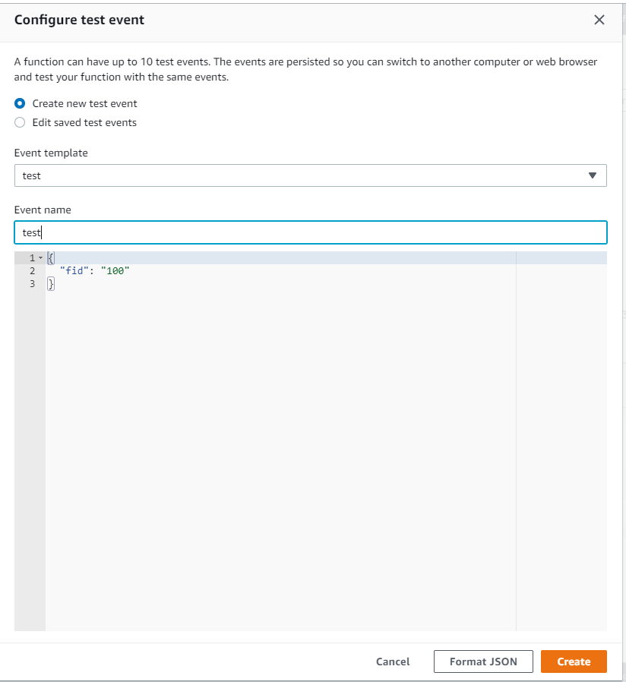

Step 8: Open the index.js file and click on the “Create” button and click on the “Test” button. Ensure that all changes have deployed before testing.

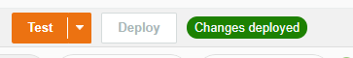

To check that the lambda function is working you should get the following response in the console:

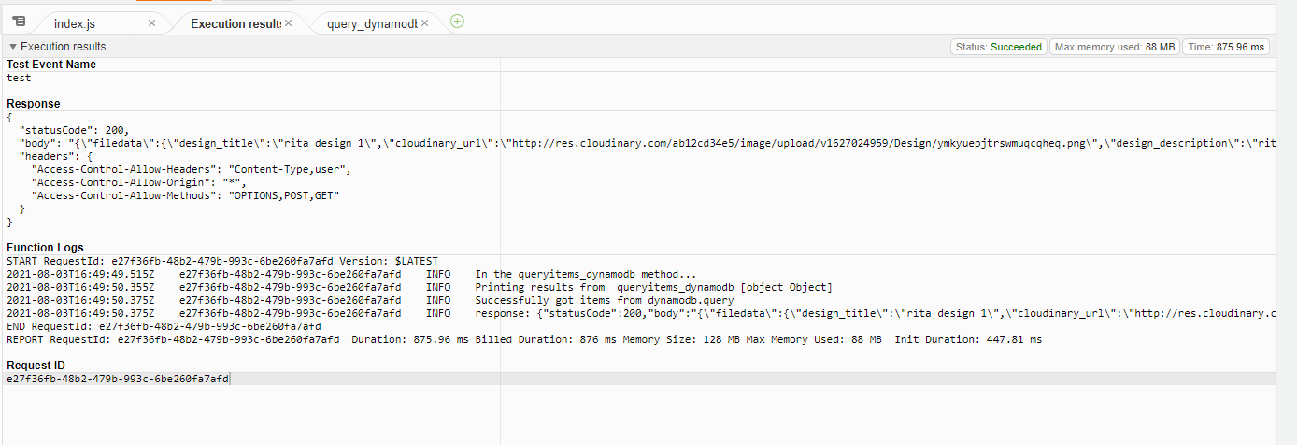

With this you have successfully created a lambda function for the updating of submission in the Bee Design website.

## **6 Creating an API with API Gateway**

API gateway is a service that allows users to create RESTful APIs and WebSocket APIs that enable real-time two-way communication applications. It acts as a gateway for applications to access data, functionalities from the user’s backend and business logic. It handles tasks such as traffic management, CORS support, authorization and access control, throttling, monitoring, and API version management. We will be creating an API gateway to build and deploy the lambda function for the updating of submission.

### 6.1 Create an API

Step 1: In the search bar of your AWS account search “api gateway” and click on the following:

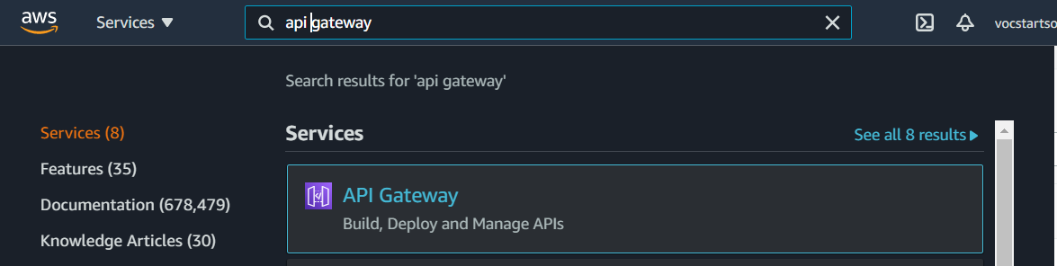

Step 2: Click on the “Create API” button

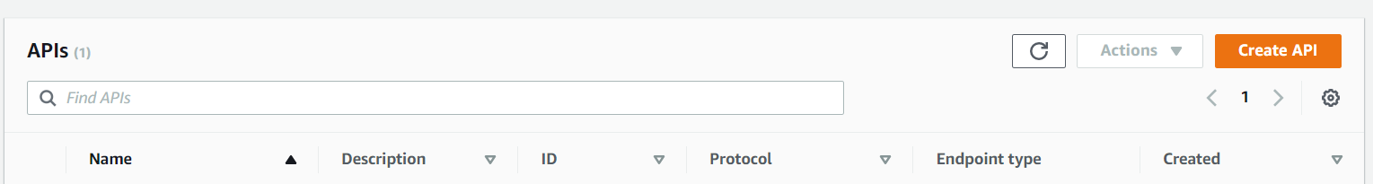

Step 3: Select “REST API” for the API type and click on the “Build” button

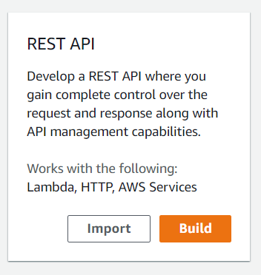

If you get this pop-up just press the “OK” button and proceed.

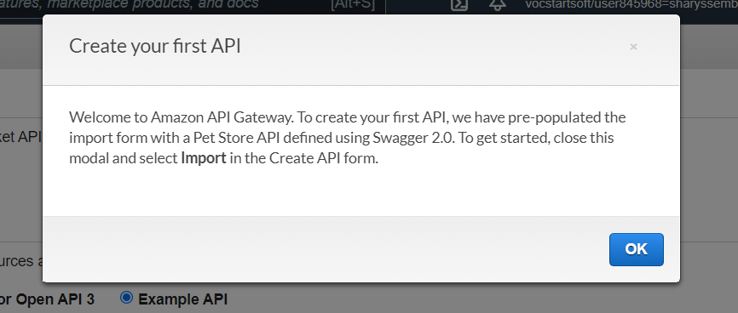

Step 4: For the API settings, leave the protocol and type of API by default. Put an API name that will state its purpose, leave the description blank and endpoint type by default.

Eg: API name: esde_beedesign_api

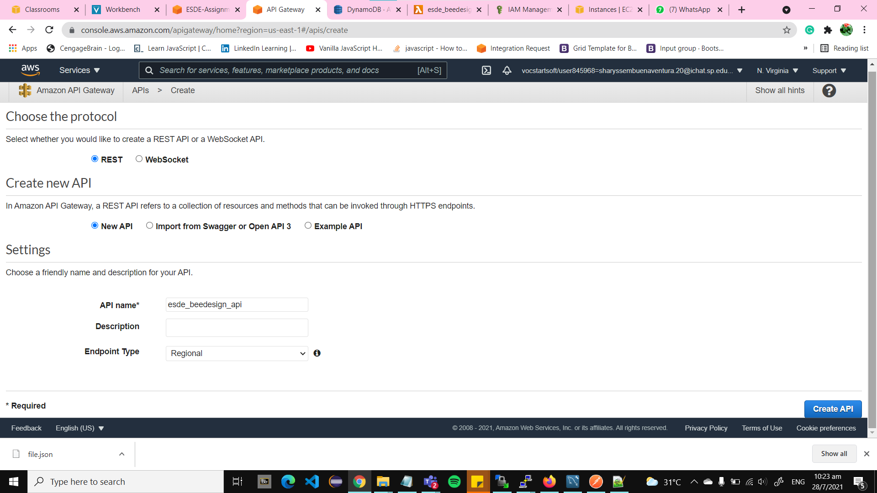

Step 5: Click on the “Create API” button and will be redirected into the created API.

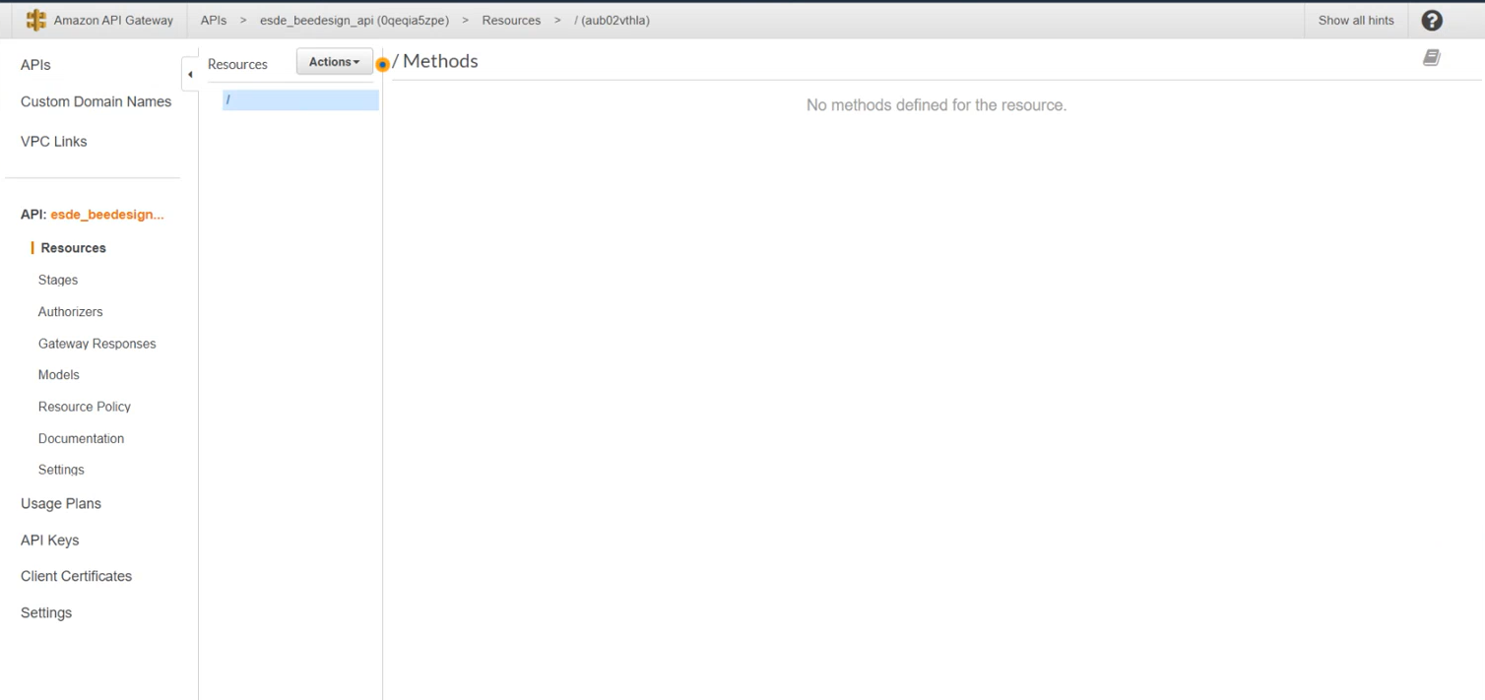

With this you have successfully created an API.

### 6.2 Create API GET Method

Step 1: Under the “Actions” button and click on “Create Method”. Select “Get” for the method and save by clicking on the check icon.

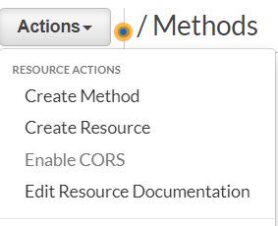 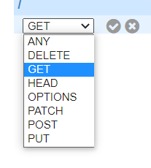

Step 2: For the “GET” method set-up; integration type: Lambda Function, Check “Use Lambda Proxy Integration”, Lambda Function “esde_beedesign_getDesignById”. Leave the Lambda Region and User Default Timeout by default.

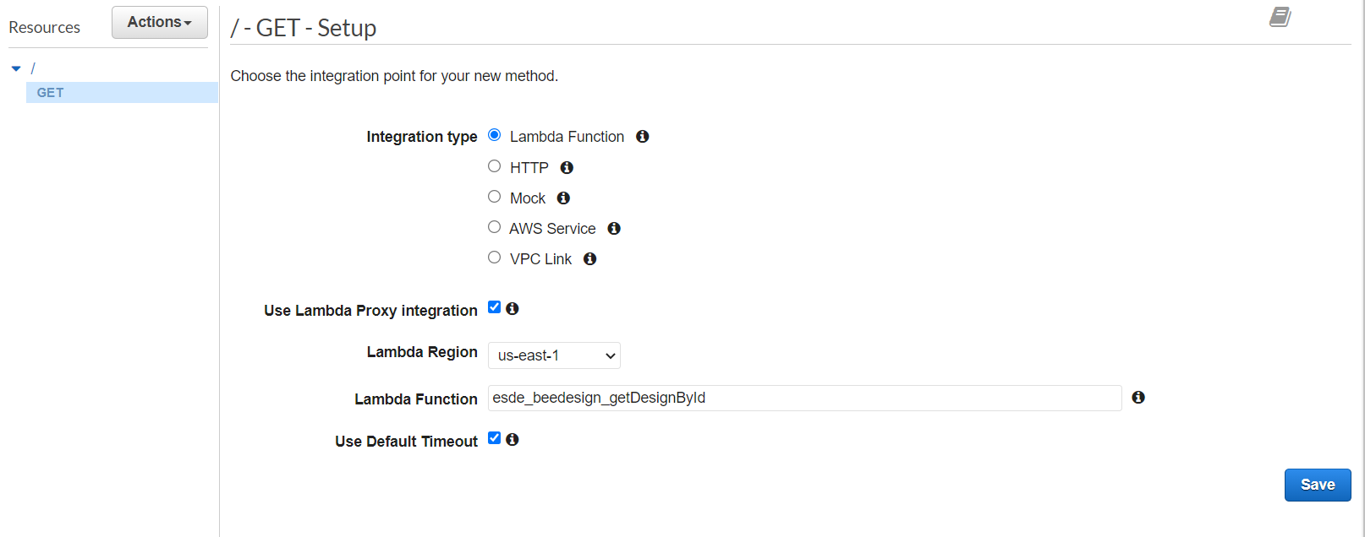

Step 3: Click on the “Save” button and you will be redirected to the GET - Method Execution page.

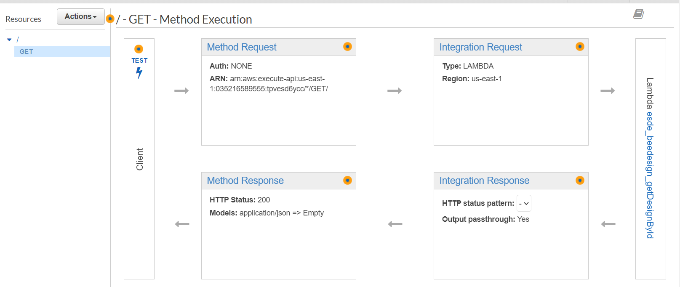

Step 4: Click on the “Integration Request” and for the settings: select Lambda Function for Integration type, check the “Use Lambda Proxy Integration” and for the execution role put the Role ARN you had saved in 5.2 step 2.

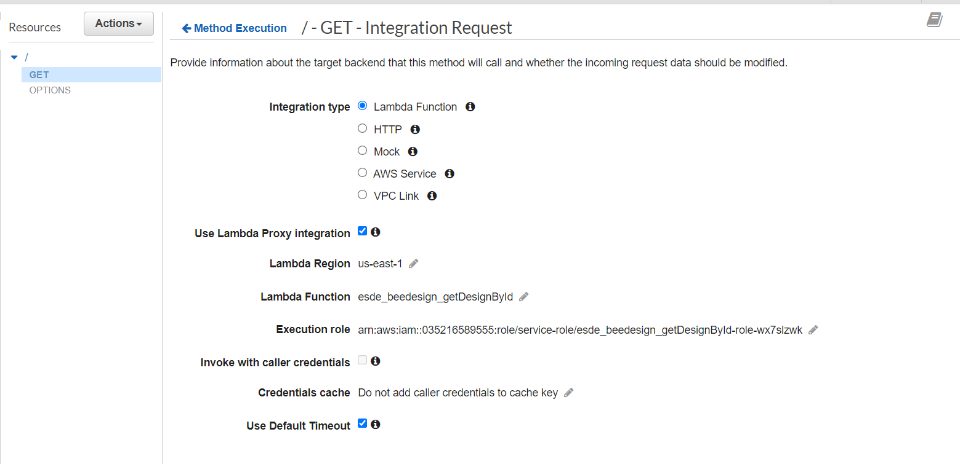

Step 5: Under the “Actions” button click on “Enable CORS”.

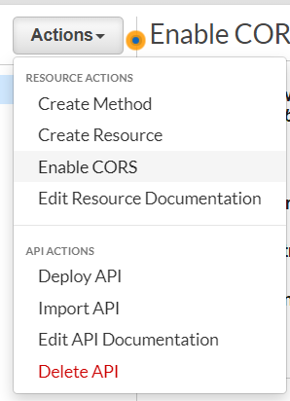

Step 6: Under “Gateway Responses for esde_beedesign_API” check the DEFAULT 4XX and

DEFAULT 5XX. At the end of “Access-Control-Allow-Headers” insert “, user” before the “ ‘ “.

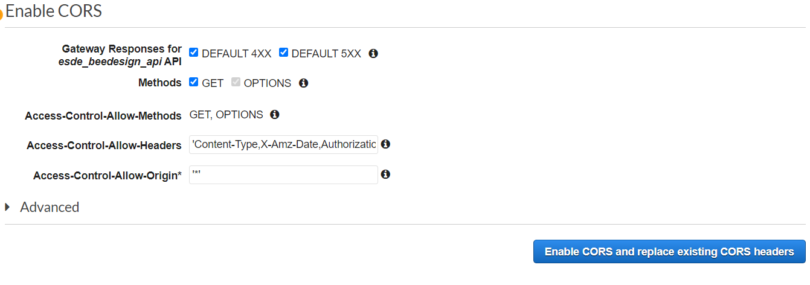

Step 7: Click on the “Enable CORS and replace existing CORS headers”. Afterwards, click on the “Yes, replace existing values”.

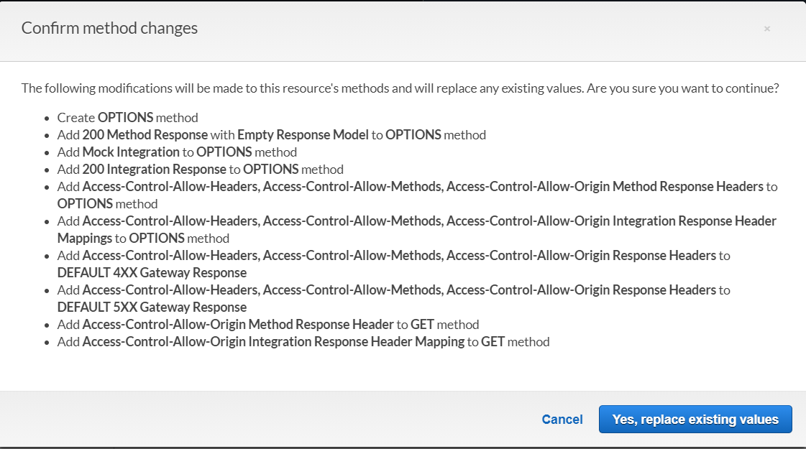

Once you have successfully enabled CORS you will get the following:

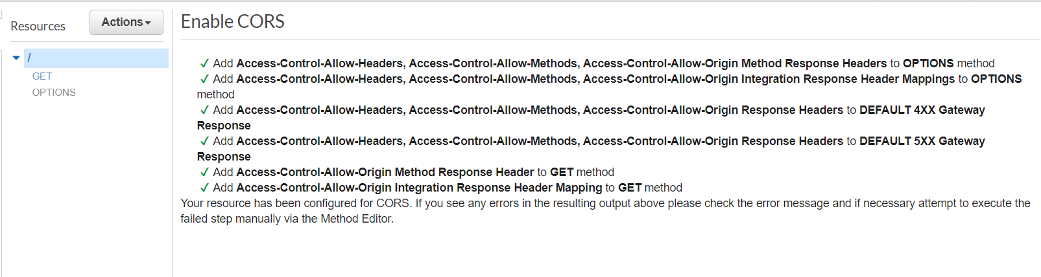

Step 8: Under the “Actions” button click on “Deploy API”.

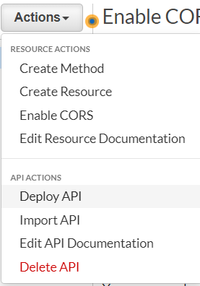

Step 9: Select [New Stage] for deployment stage and name the stage and description “test”.

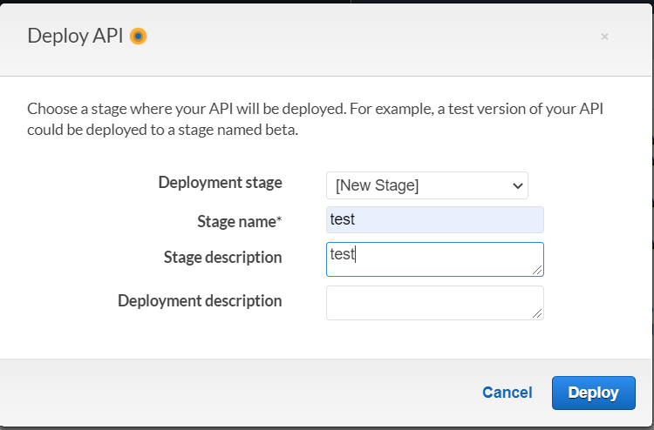

Step 10: Click on the “Deploy” button and you will be redirected to the test Stage Editor page.

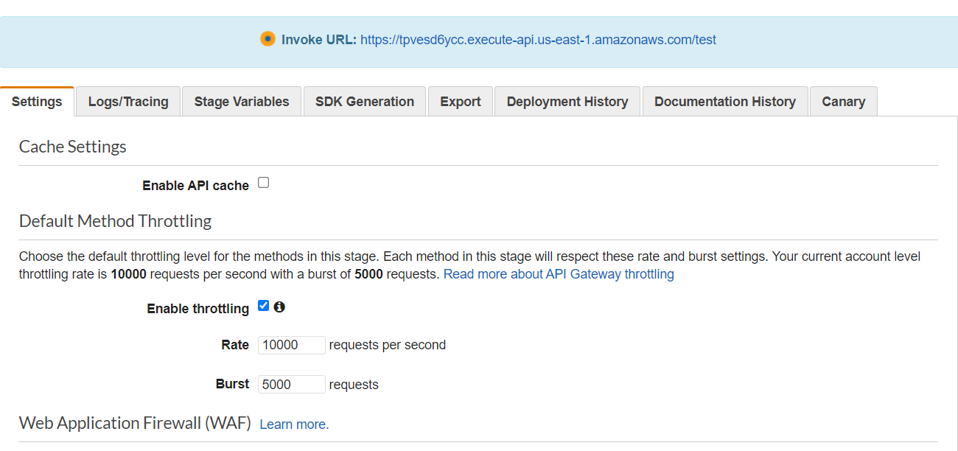

### 

### 6.3 Testing of API

We will test the API within AWS first before testing it on the actual Bee Design website.

Step 1: Copy the invoke URL and paste in a notepad as we will be using the URL in the latter steps. Afterwards go to the GET - Method Execution page and click on “Method Request”



Step 2: Expand URL Query String Parameters and click on the "Add query string" button. Put “fid” for the name and click on the check icon to save the string.

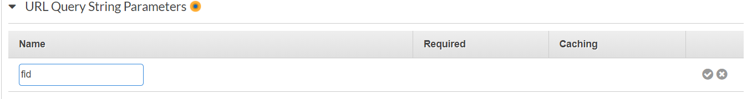

Step 3: Go back to the main GET - Method Execution page by clicking on the “Method Execution”

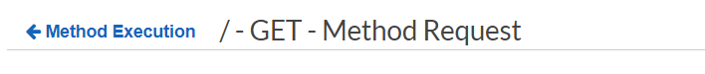

Step 4: Click on the “Test” lightning bolt icon and you will be redirected to the GET - Method Test Page.

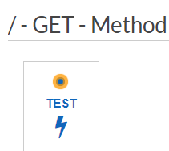

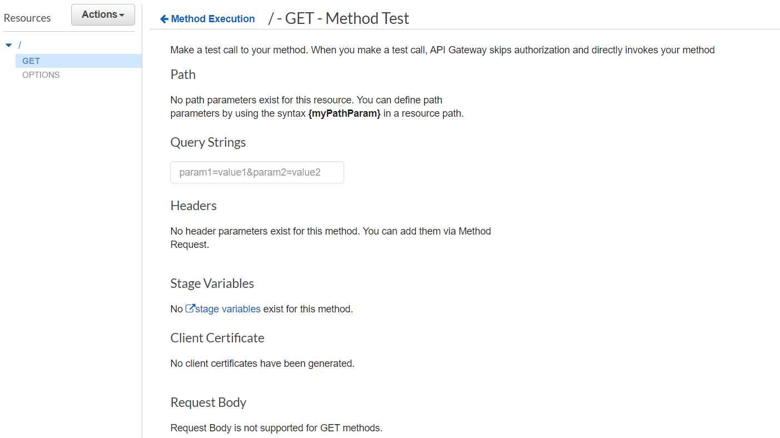

Step 5: Insert “fid=100” into the “Query Strings” input box, scroll all the way down and click on the “Test” button.

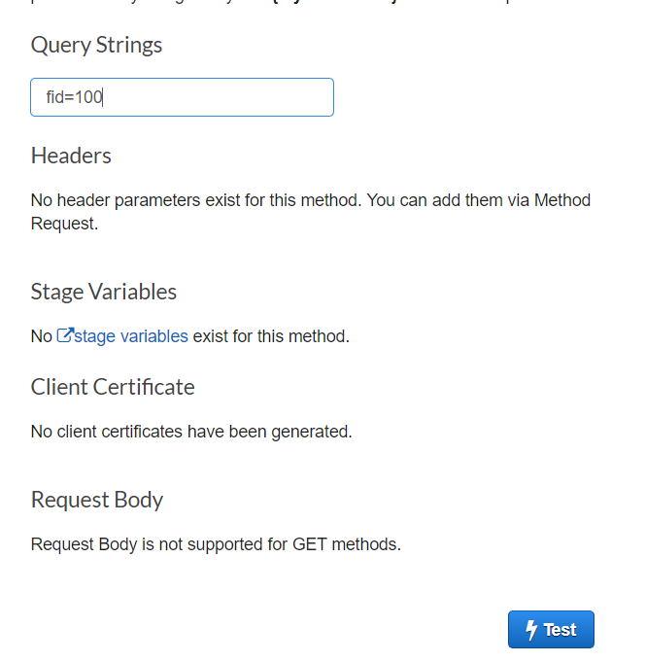

If your testing is successful, you should get the following response:

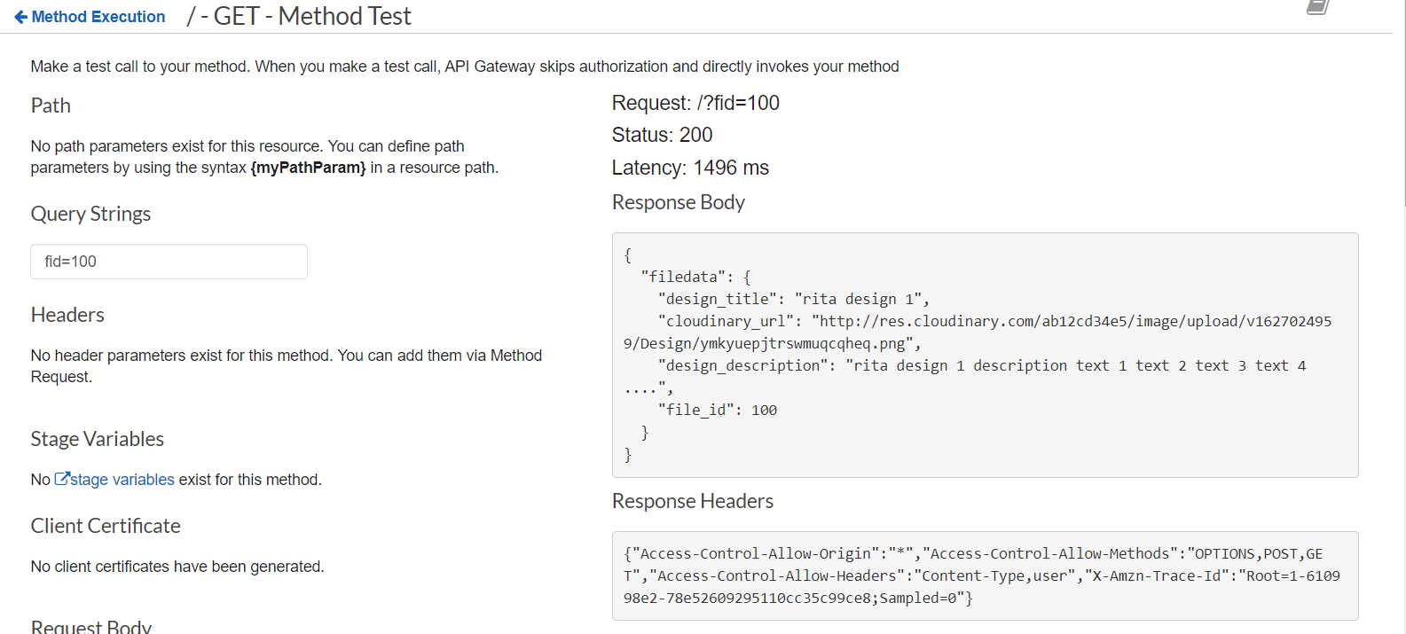

With this you have successfully tested the API within AWS.

### 6.4 Implementing the API into Frontend Server

We will not be changing the current API being used in the fronted server to the new serverless API we created with AWS.

Step 1: Open your WinSCP and navigate to “update_desgin.js” under the frontend and public folder.

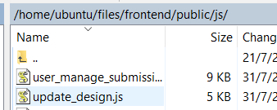

Step 2: Edit the “update_desgin.js” file and go to the function getOnedata(). Comment out the URL and insert the following code and save the file.

url:'https://the invoke url you copied in step 1?fid=' + fileId,

Eg: url:'https://tpvesd6ycc.execute-api.us-east-1.amazonaws.com/test?fid=' + fileId,

It should look like the following:

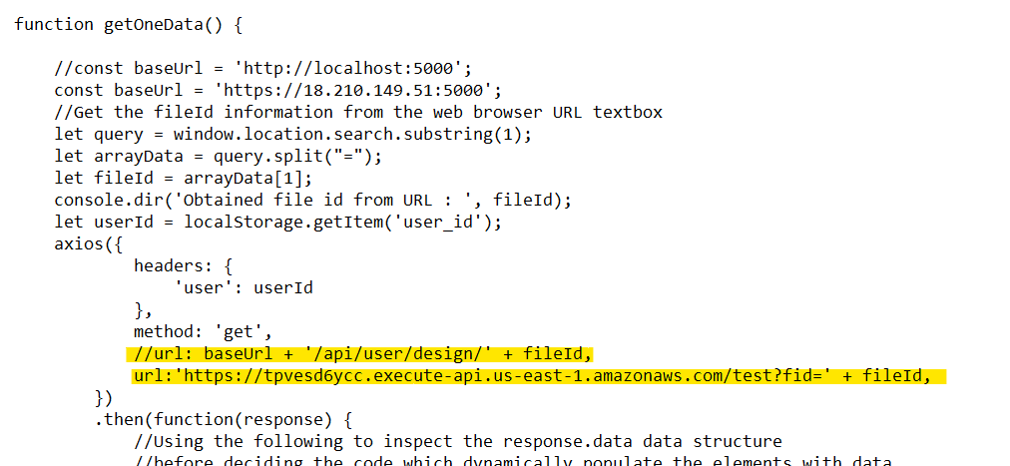

Step 2: Test the Bee Design Website by clicking on the update button of any submission and changing the name or description then clicking the “save” button. Click on the same submission and check that the changes you have made have been saved.

Eg: rita design 1

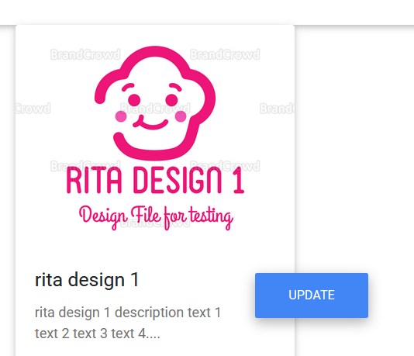

Eg: Changed the description to “hello”

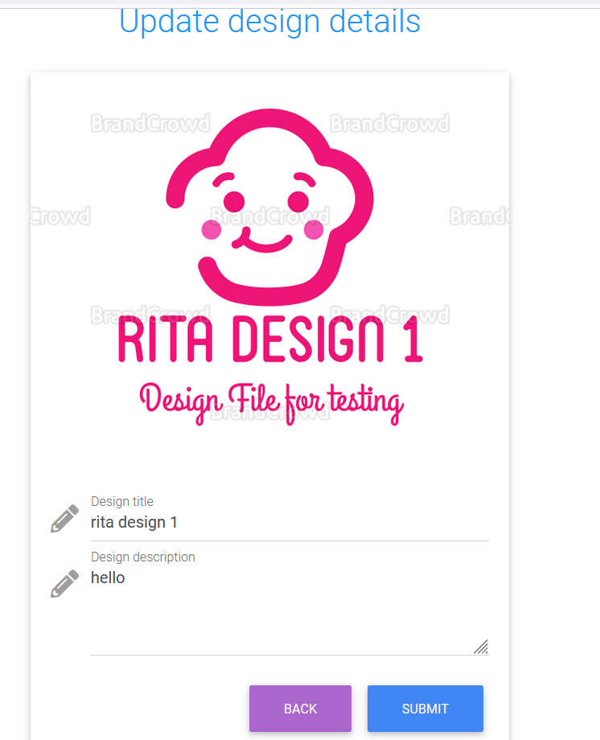

With this you have successfully created a serverless API using AWS.

## **7 Setting Up CloudWatch Logging For Created API**

CloudWatch logging allows all activities done in REST API created in API gateway to be recorded. There are two types of CloudWatch logging: execution logging and access logging. Execution logging the API gateway manages the CloudWatch logs while in access logging the developer created their own logging group or an existing log group that can be managed by API gateway. For the API we have created we will be using execution logging.

### 7.1 Create CloudWatch Role

Step 1: Go the IAM for esde_beedesign_getDesignById and under permission click on the “Attach Policies”

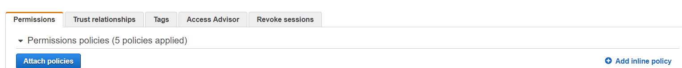

Step 2: Search “AmazonAPIGatewatPushToCloudWatchLogs”, select the following and click on the “Attach policy” button.

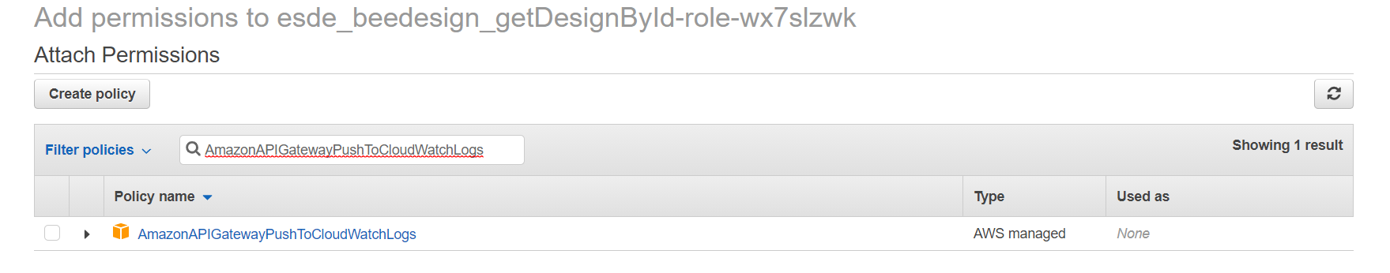

Step 3: Go to the IAM and under the side menu click on “Role”.

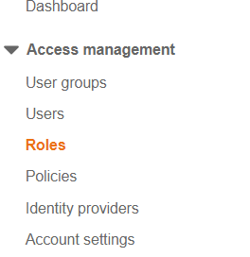

Step 4: Click on the “Create role” button.

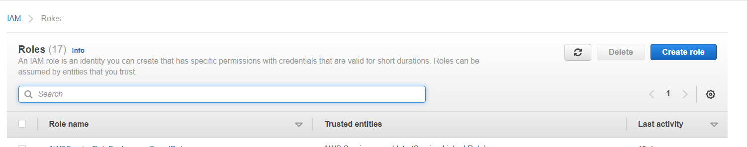

Step 5: For the role settings: for type of trusted entity: AWS service, use case: API Gateway.

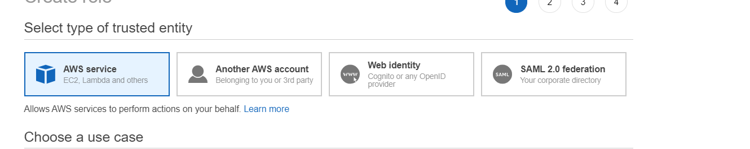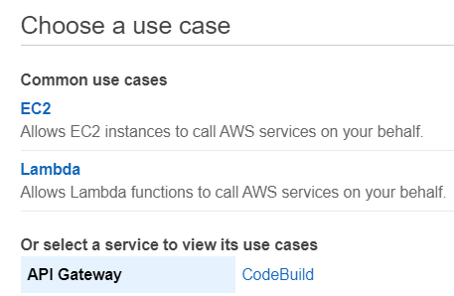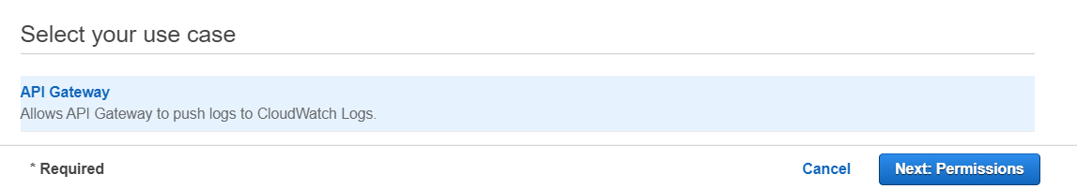

Step 6: Click on the “Next: Permissions” and by default “AmazonAPIGatewayPushToCloudWatchLogs” is selected.

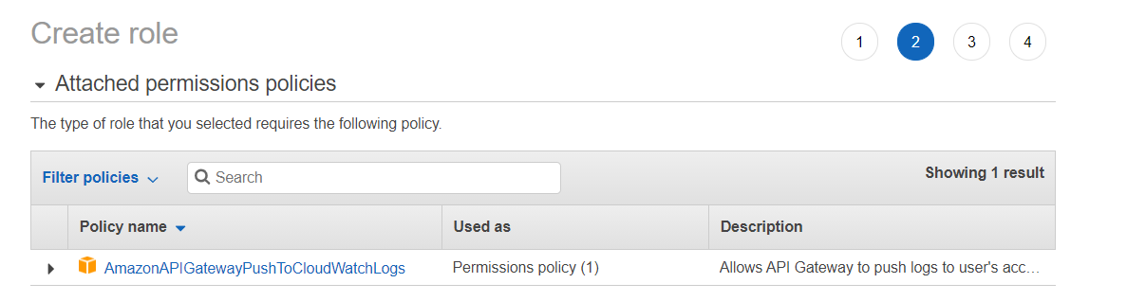

Step 7: Click on the “Next: Tags” and we will be leaving the tags by default. Afterwards click on the “Next: Review”.

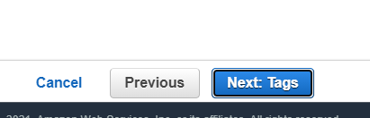 → 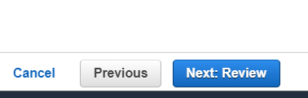

Step 8: For the role name put one that you will be able to tell its function and leave the description by default. Check that all the settings are correct and click on the “Create role” button. You will be redirected to the roles page.

Eg: Role name: esde_beedesign_cloudwatch

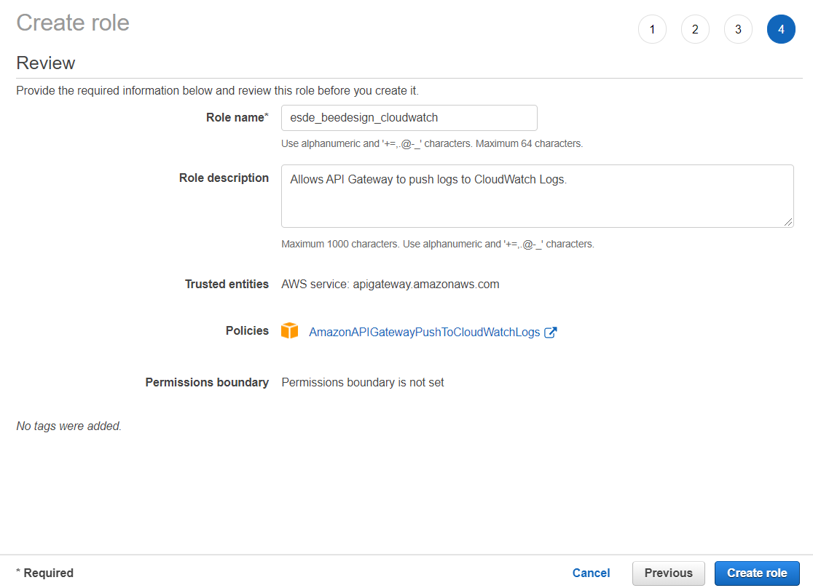

Step 9: In the search bar search the CloudWatch role you have created and click on it.

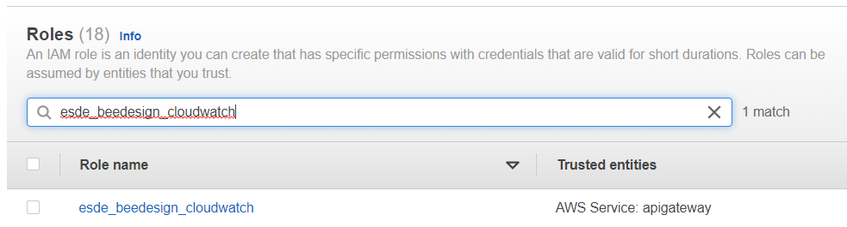

Step 10: Copy the Role ARN and paste in a notepad as we will be using this on the latter steps.

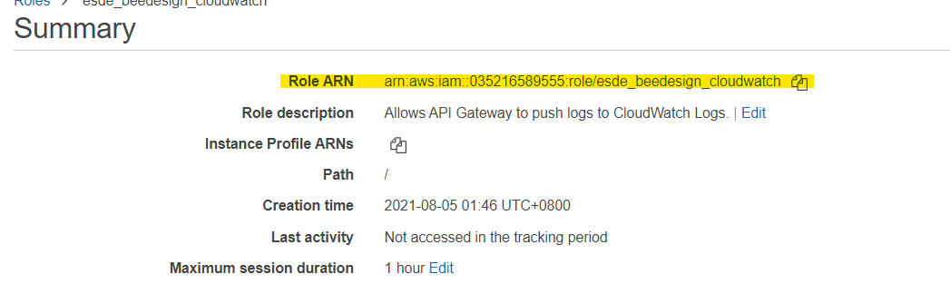

With this you have successfully created a CloudWatch role.

### 7.2 Creating a Log Group

Step 1: In the search bar of your AWS account search “CloudWatch” and click on the following:

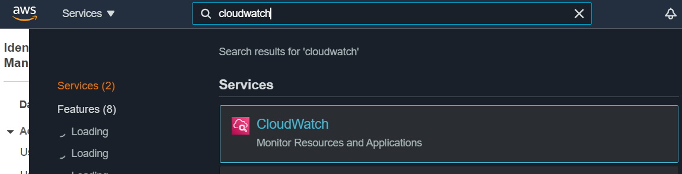

Step 2: under the side menu and under the “Logs” click on the “Log groups”.

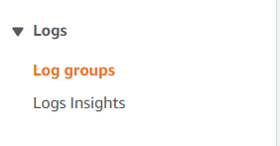

Step 3: Click on the “Create log group” button.

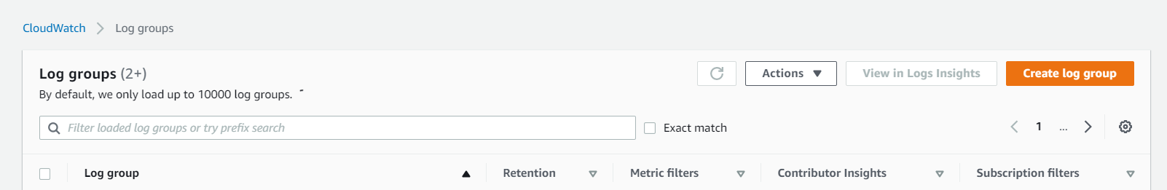

Step 4: For log group details: use a log group name that you will be able to tell what its function is.

Eg: esde_cloudwatchlog

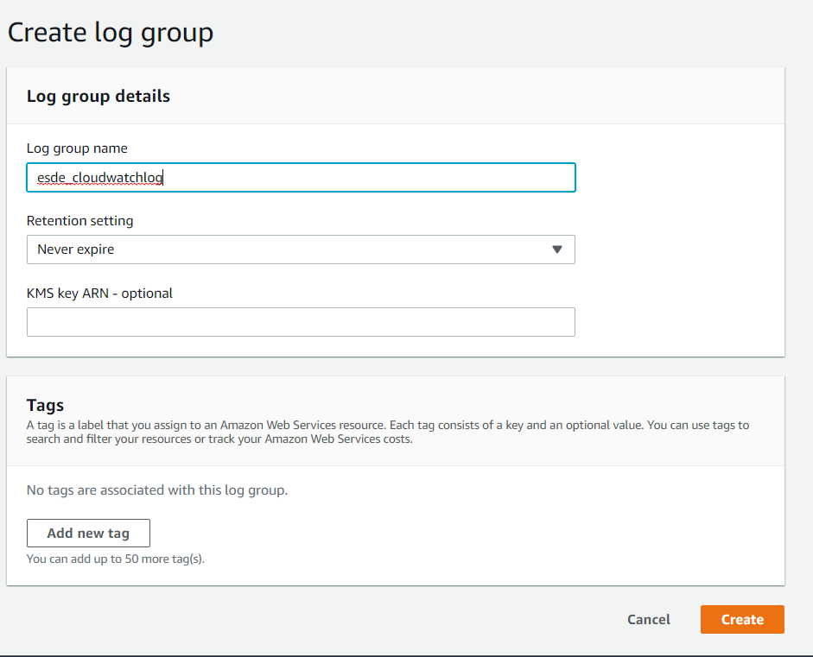

With this you have successfully created a log group.

### 7.3 Add CloudWatch IAM Role to API Gateway

Step 1: Go to your API gateway and under the side menu click on the settings.

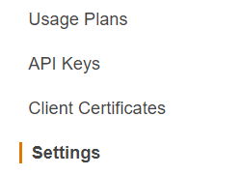

Step 2: In the CloudWatch log role ARN input box paste the role ARN you have copied. Afterwards, click on the “Save” button there will be no pop-up message to indicate that the changes have been saved.

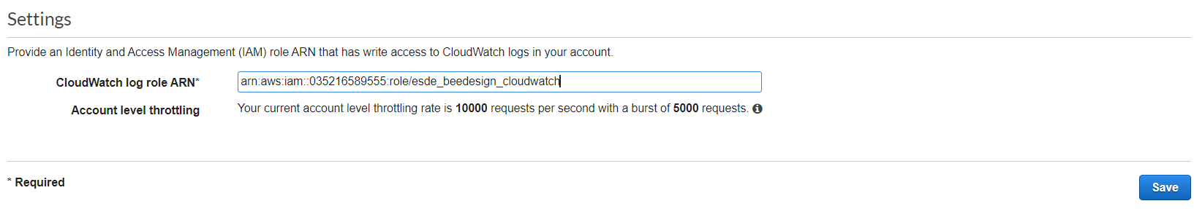

Step 3: Go to the API you have created in the previous section and on the side menu click “Stages”.

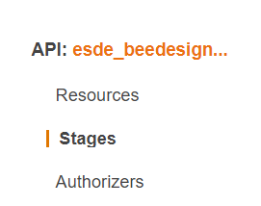

Step 4: Under “Logging/Tracing” for the CloudWatch settings; check “Enable CouldWatch Logs”, select “ERROR” for log level and check “Enable Detailed CloudWatch Metrics.

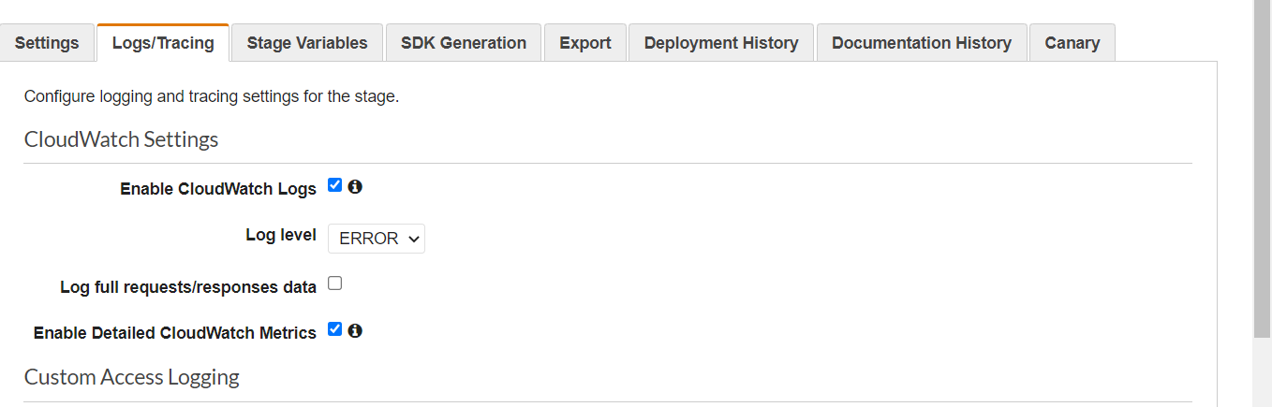

Step 5: For the Custom Access Logging settings; check “Enable Access Logging”,

Access Log Destination ARN : arn:aws:logs:*{region}*:*{account-id}*:log-group:*log-group-name*, for log format click on the json button.

Eg : arn:aws:logs:us-east-1:035216589555:log-group:esde_cloudwatchlog

You can find your account id under the dropdown menu of your name

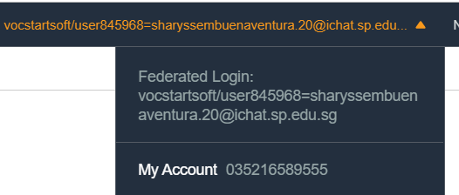

It should look like the following:

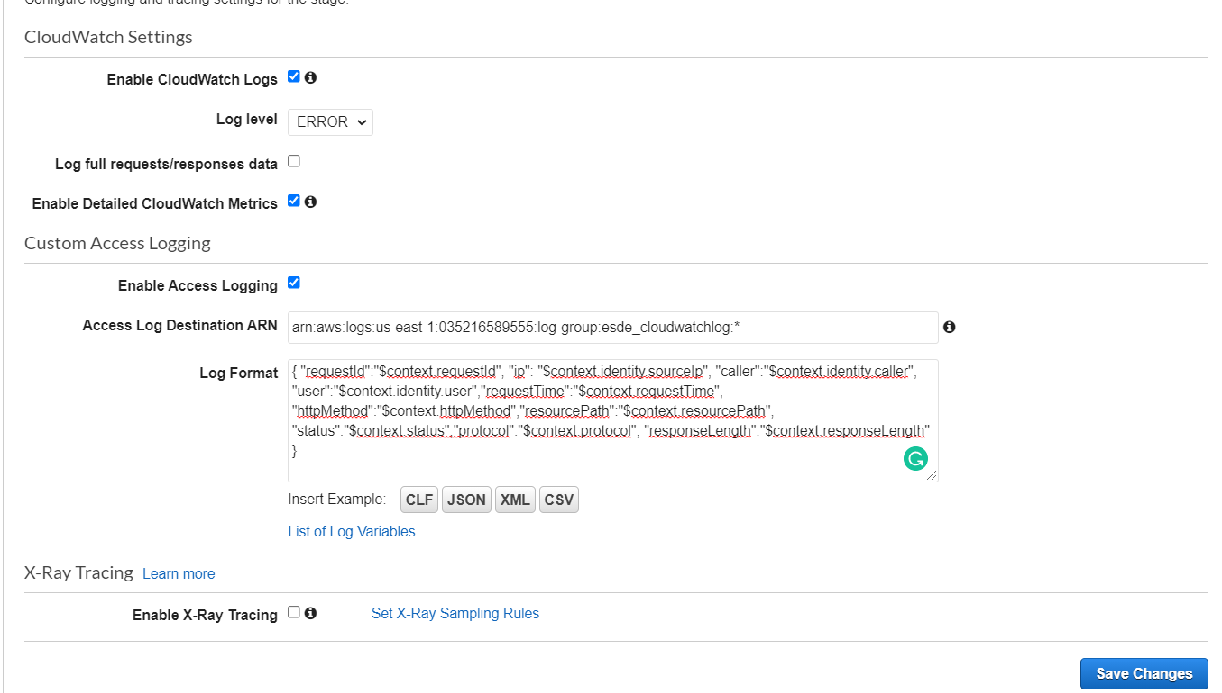

Step 6: Click on the “Save changes” button. There will be no pop-up message to indicate that the changes have been saved.

With this you have implemented the CloudWatch into the API you have created in API gateway.

### 7.4 Testing the CloudWatch Logging

Step 1: Open with your bee design website and ensure that both backend and frontend servers are running in their respective PuTTYgen terminals.

Step 2: Log in as username: “[rita@designer.com](mailto:rita@designer.com)” and password: “password”.

Step 3: Click on any of the submission and edit the name or description or both up to you.

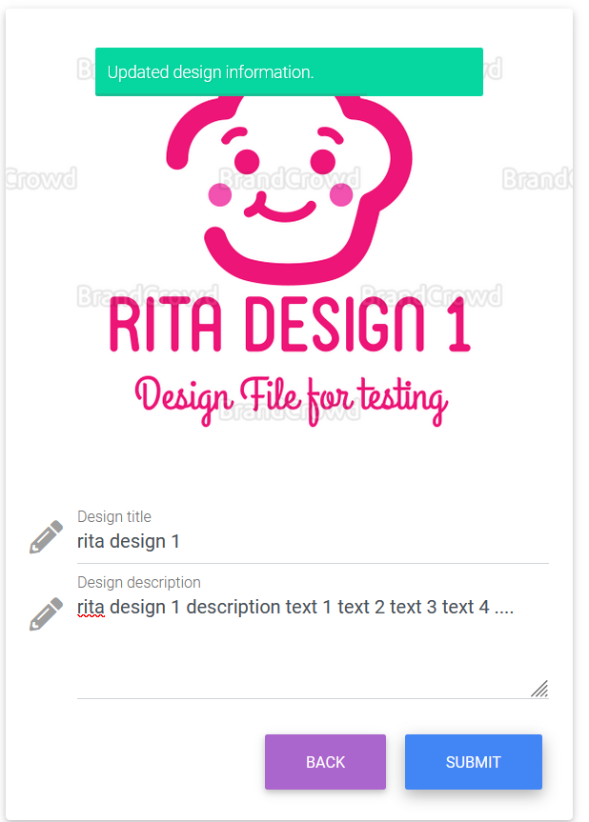

Step 4: Go to the created CloudWatch log group and you should see the following:

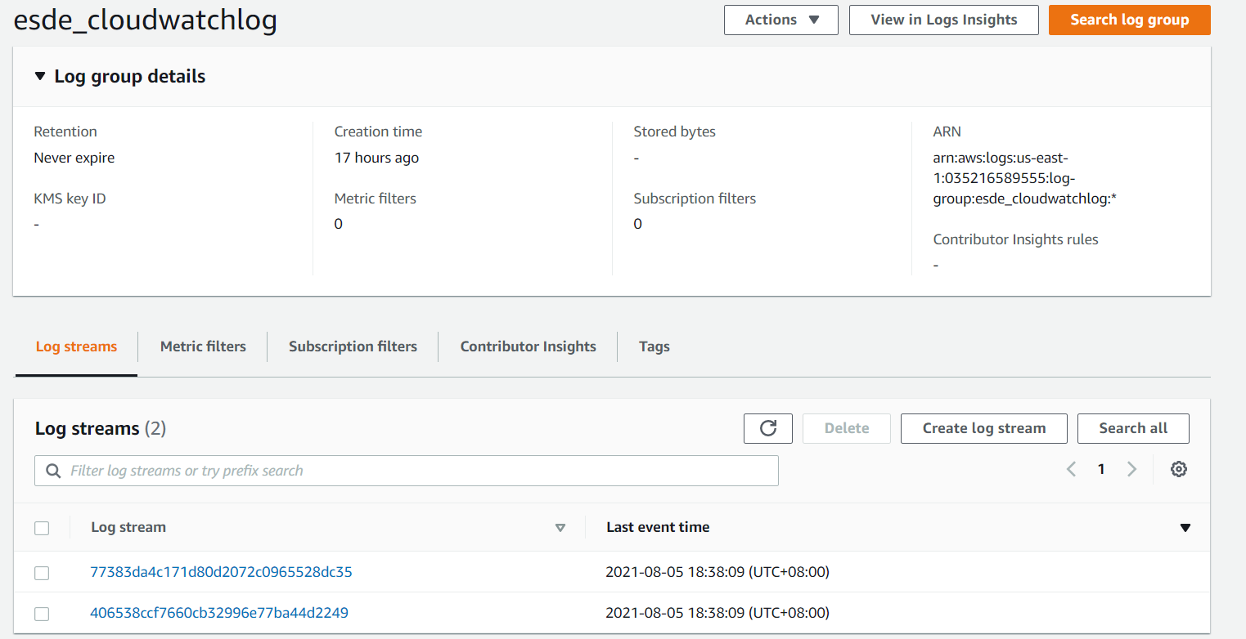

Step 5: Click on one of the log streams and expand the timestamp. You should see the following:

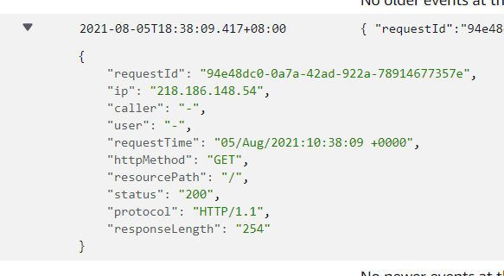

With this you have successfully created a CloudWatch log for your API.

## **8 Cloud Trail**

Cloud Trail is a service that enables governance, compliance, operational auditing, and risk auditing of your AWS account. Cloud Trail will record events of a user’s AWS account including services used and actions done in the services. It can be used to detect suspicious activities that have occurred in a user’s account. Cloud trail also simplifies security analysis, resource change tracking, and troubleshooting. We will now be creating a cloud trail for us to monitor our AWS activities.

Step 1: In the search bar of your AWS account search “cloudtrail” and select on the following:

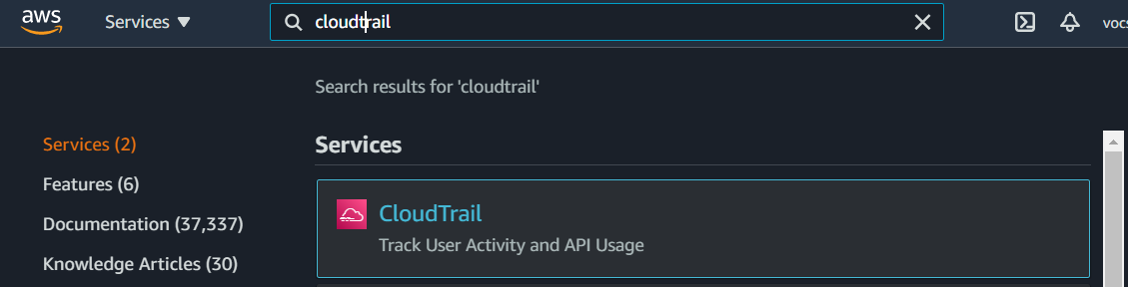

Step 2: Click on the “Create a trail” button

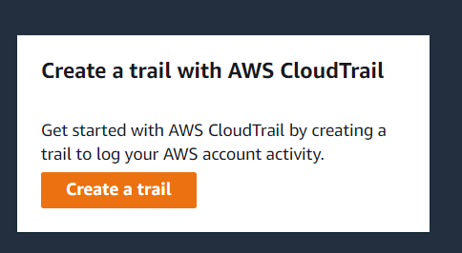

Step 3: You can leave the trail name by default or name it to your preference. Afterwards, click on the “Create trail” button.

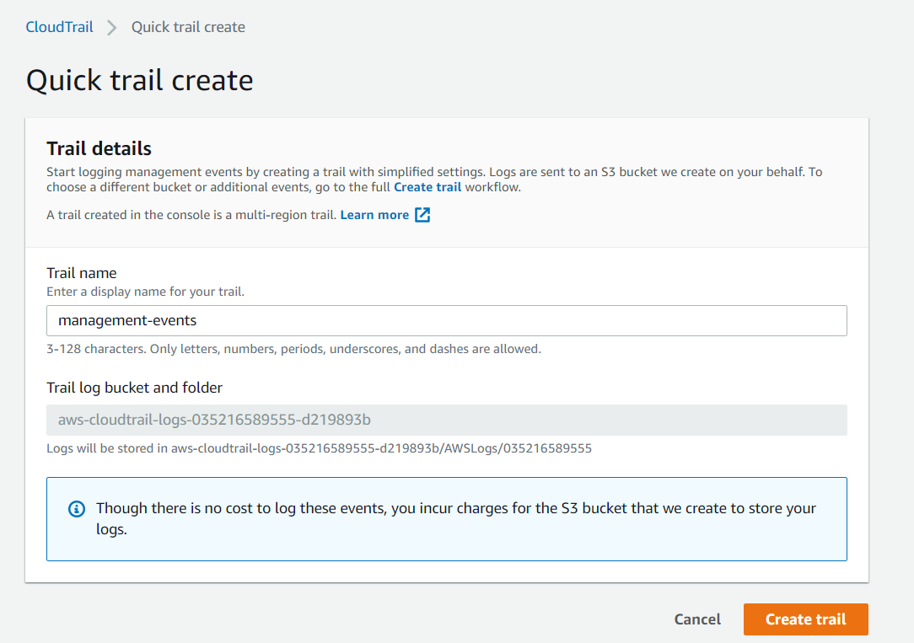

Step 4: Check that the created trail status is “logging”.

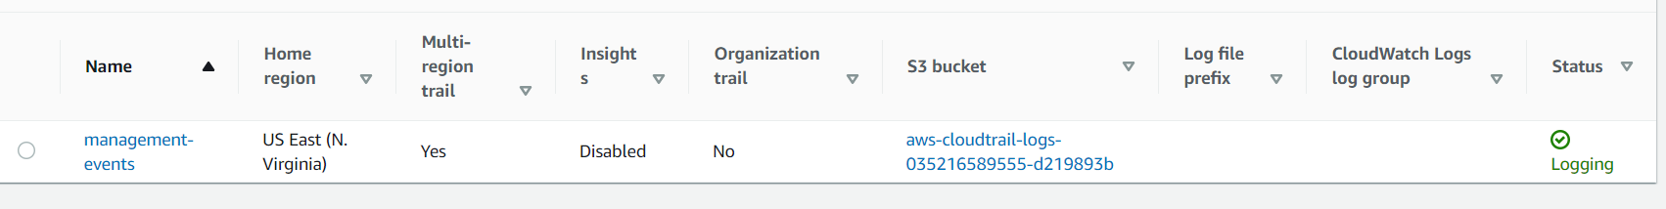

With this you have successfully created a cloud trail.